**Supplemental Material I**

**Table S1.** Main prey of CCE predators, as indicated by >20% by mass or number in the diet. See text for location abbreviations.

|  |  |  |  |  |  |  |  |
| --- | --- | --- | --- | --- | --- | --- | --- |
| Predator | Site | Anchovy | Sardine | Market squid | Juv. rockfish | Other | Source |
| Common murre | SFI | x |  | x | x |  | Sydeman et al*.* 2001, 2009 |
| Rhinoceros auklet | SFI | x |  | x | x |  | Thayer & Sydeman 2007 |
| ANI | x |  | x | x |  | Thayer & Sydeman 2007 |
| Brandt’s cormorant | SFI | x |  |  | x | sanddab (*Citharicthys* sp.) | Ainley et al*.* 1981, Elliott et al*.* 2015 |
| ANI | x |  |  | x | sanddab (*Citharicthys* sp.) | J. Thayer et al*.* unpublished data |
| ALCZ | x |  |  | x | sanddab (*Citharicthys* sp.) | Yakich 2005 |
| Pelagic cormorant | SFI |  |  |  | x | sculpin (Cottidae) | Ainley et al*.* 1981 |
| ANI |  |  |  | x | sculpin (Cottidae) | J. Thayer et al*.* unpublished data |
| Pigeon guillemot | SFI |  |  |  | x | sculpin (Cottidae) | Sydeman et al*.* 2001 |
| Brown pelican | SBI | x | x |  |  |  | Sunada et al*.* 1980, Gress et al*.* 1980, Harvey & Gress 2008 |
| ANA | x | x |  |  |  |
| Least tern | VB | x |  |  |  | silversides (Atherinidae) | Atwood & Kelly 1984 |
| California sea lion * | SCI | x | x | x |  |  | Lowry et al*.* 1991, 1999, Antonelis et al*.* 1990; Melin et al. 2012 |
| SBI | x | x | x |  |  |
| SMI | x | x | x |  |  |
| SNI | x | x | x |  |  |
| Chinook salmon | CV | x | x | x | x | krill (Euphausiidae) | Thayer et al*.* 2014, Hunt et al. 1999, Merkel 1957 |

*\* For CASL in the southern CCE, only % frequency of occurrence of prey in the diet was available, so main prey represent > 40% of %FO.*

**Table S2.** Individual predator-prey relationships for marine birds, mammals and fish in the central and southern CCE, preying on

northern anchovy, Pacific sardine, juvenile rockfish and market squid.1 See Table 1 for predator indexdefinitions.

|  |  |  |  |  |  |  |  |  |  |  |  |  |  |
| --- | --- | --- | --- | --- | --- | --- | --- | --- | --- | --- | --- | --- | --- |
| **Predator** |  | | **Region** | **Specific location** | | **Predator index** | | **1˚ prey threshold** | | **Years modeled** | | **N spp-yrs** | |
| **1˚ prey** | |
|  | **Anchovy** | |  |  | |  | |  | |  | | **292** | |
| Brandt's cormorant | Anchovy | | central CA | SE Farallon Isl. | | RS | | -0.20 (27%) | | 1975-2011 | | 32 | |
| Brandt's cormorant | Anchovy | | central CA | Año Nuevo Isl. | | RS | | -0.08 (30%) | | 2002-2011 | | 10 | |
| Brandt's cormorant | Anchovy | | central CA | Alcatraz Isl. | | RS | | -0.41 (21%) | | 1995-2011 | | 17 | |
| Common murre | Anchovy | | central CA | SE Farallon Isl. | | RS | | -0.48 (20%) | | 1975-2011 | | 32 | |
| Rhinoceros auklet | Anchovy | | central CA | SE Farallon Isl. | | RS | | no threshold* | | 1986-2013 | | 28 | |
| Rhinoceros auklet | Anchovy | | central CA | Año Nuevo Isl. | | RS | | no threshold* | | 1994-2013 | | 20 | |
| Brown pelican | Anchovy | | southern CA | Anacapa Isl. | | RS | | -0.17 (~35%) | | 1975-2004 | | 24 | |
| Brown pelican | Anchovy | | southern CA | Santa Barbara Isl. | | RS | | -0.61 (~20%) | | 1986-2003 | | 16 | |
| Least tern | Anchovy | | southern CA | Venice Beach | | RS* | | -0.35 (~22%) | | 1978-2011 | | 22 | |
| CA sea lion | Anchovy | | southern CA | San Clemente Isl. | | Pup | | -0.36 (~29%) | | 1975-2000 | | 21 | |
| CA sea lion | Anchovy | | southern CA | Santa Barbara Isl. | | Pup | | no threshold* | | 1975-2000 | | 21 | |
| CA sea lion | Anchovy | | southern CA | San Miguel Isl. | | Pup | | -0.36 (~23%) | | 1975-2011 | | 32 | |
| CA sea lion | Anchovy | | southern CA | San Nicolas Isl. | | Pup | | no threshold* | | 1975-2000 | | 21 | |
|  | **Rockfish (juv.)** | |  |  | |  | |  | |  | | **182** | |
| Common murre | Rockfish (juv.) | | central CA | SE Farallon Isl. | | RS | | -0.21 (~41%) | | 1983-2013 | | 31 | |
| Rhinoceros auklet | Rockfish (juv.) | | central CA | SE Farallon Isl. | | RS | | -0.93 (~25%) | | 1986-2013 | | 28 | |
| Rhinoceros auklet | Rockfish (juv.) | | central CA | Año Nuevo Isl. | | RS | | no threshold* | | 1994-2013 | | 20 | |
| Pigeon guillemot | Rockfish (juv.) | | central CA | SE Farallon Isl. | | RS | | -0.72 (~30%) | | 1983-2013 | | 31 | |
| Pelagic cormorant | Rockfish (juv.) | | central CA | SE Farallon Isl. | | RS | | -0.98 (~24%) | | 1983-2013 | | 31 | |
| Pelagic cormorant | Rockfish (juv.) | | central CA | Año Nuevo Isl. | | RS | | -1.4 (~25%) | | 1996-2012 | | 17 | |
| Chinook salmon | Rockfish (juv.) | | central CA | Central Valley | | Returns | | -0.83 (~27%) | | 1983-2006 | | 24 | |
| **Predator** |  | **Region** | | | **Specific location** | | **Predator index** | | **1˚ prey threshold** | | **Years modeled** | | **N spp-yrs** | |
| **1˚ prey** |
|  | **Sardine** |  | | |  | |  | |  | |  | | **79** | |
| Brown pelican | Sardine | southern CA | | | Anacapa Isl. | | RS | | *not enough obs* | | 1992-2004 | | 11 | |
| Brown pelican | Sardine | southern CA | | | Santa Barbara Isl. | | RS | | *not enough obs* | | 1992-2003 | | 10 | |
| CA sea lion | Sardine | southern CA | | | San Clemente Isl. | | Pup | | *not enough obs* | | 1992-2000 | | 8 | |
| CA sea lion | Sardine | southern CA | | | Santa Barbara Isl. | | Pup | | *not enough obs* | | 1992-2000 | | 8 | |
| CA sea lion | Sardine | southern CA | | | San Miguel Isl. | | Pup | | -0.39 (~29%) | | 1992-2011 | | 19 | |
| CA sea lion | Sardine | southern CA | | | San Nicolas Isl. | | Pup | | *not enough obs* | | 1992-2000 | | 8 | |
| Chinook salmon | Sardine | central CA | | | Central Valley | | Returns | | -0.31 (31%) | | 1992-2006 | | 15 | |
|  | **Market squid** |  | | |  | |  | |  | |  | | **72** | |
| CA sea lion | Market squid | southern CA | | | San Clemente Isl. | | Pup | | *not enough obs* | | 1997-2000 | | 4 | |
| CA sea lion | Market squid | southern CA | | | Santa Barbara Isl. | | Pup | | *not enough obs* | | 1997-2000 | | 4 | |
| CA sea lion | Market squid | southern CA | | | San Miguel Isl. | | Pup | | -0.73 (~22%) | | 1997-2011 | | 15 | |
| CA sea lion | Market squid | southern CA | | | San Nicolas Isl. | | Pup | | *not enough obs* | | 1997-2000 | | 4 | |
| Common murre | Market squid | central CA | | | SE Farallon Isl. | | RS | | -0.70 (~23%) | | 1997-2011 | | 15 | |
| Rhinoceros auklet | Market squid | central CA | | | SE Farallon Isl. | | RS | | -0.34 (~34%) | | 1997-2011 | | 15 | |
| Rhinoceros auklet | Market squid | central CA | | | Año Nuevo Isl. | | RS | | -0.37 (~33%) | | 1997-2011 | | 15 | |

*\* In all cases for which there were sufficient observations but the model did not converge to calculate a threshold, data in the upper left quadrant of curve, when prey abundance was high yet predator productivity was low, signaled alternate prey use precluding a significant relationship with just one prey species.*

1 Data sources in the central CCE included Garcia-Reyes et al. 2013, Leising et al*.* 2014, Elliott et al*.* 2015, and Point Blue Conservation Science/US Fish & Wildlife Service unpublished report (Warzybok et al*.* 2014) for SE Farallon Island seabirds; Thayer and Sydeman 2007, Garcia-Reyes et al. 2013, Carle et al*.* 2014, Oikonos unpublished report (Carle et al*.* 2014), and J. Thayer unpublished data for Año Nuevo Island seabirds; Saenz et al*.* 2006 and Farallon Institute/National Park Service (NPS) unpublished report (Robinson et al*.* 2014) for Alcatraz Island seabirds; Kilduff et al*.* 2014 and P. Kilduff unpublished data for Chinook salmon. Central CCE prey data came from the National Marine Fisheries Service SWFSC Rockfish Recruitment and Ecosystem Assessment Survey (J. Field and K. Sakuma/NOAA; also see Ralston et al*.* 2014, Davison et al*.* in prep). Southern CCE data sources included Lowry and Maravilla 2005, Melin et al. 2012, and Caretta et al*.* 2014 for Channel Islands sea lions; California Department of Fish & Wildlife (CDFW) unpublished report (Burkett et al*.* 2007), Sutil Conservation Ecology/NPS unpublished report (Harvey and Mazurkiewicz 2014), and F. Gress unpublished data for Channel Islands brown pelicans; Massey et al*.* 1992, H.T. Harvey & Associates/US Army Corps Engineers unpublished report (Burton and Terrill 2012), and CDFW unpublished report (Frost 2014) for least terns. Southern CCE prey data came from CalCOFI surveys (S. McClatchie and E. Weber/NOAA; also see Smith and Moser 2003, Koslow et al*.* 2011, MacCall et al*.* 2015, Davison et al*.* in prep).

**Figure S1.** Relationships of individual predator productivity with prey abundance at distinct locations throughout the central/southern CCS. All x-axes represent prey abundance, while all y-axes represent predator productivity. Abundance of **I)** anchovy prey relative to productivity of a) Brandt’s cormorants at SE Farallon Island (SFI), b) Año Nuevo Island (ANI) and c) Alcatraz Island (ALZ), d) common murre at SFI, e) rhinoceros auklet at SFI and f) ANI, g) brown pelican at Santa Barbara Island (SBI) and h) Anacapa Island (ANA), i) least tern at Venice Beach (VB), and j) California sea lions at San Miguel Island (SMI) k) San Clemente Island (SCI), l) SBI, and m) San Nicolas Island (SNI); **II)** juvenile rockfish prey relative to productivity of a) common murre at SFI, b) rhinoceros auklet at SFI and c) ANI, d) pelagic cormorant at SFI and e) ANI, f) pigeon guillemot at SFI, and g) Chinook salmon from the Central Valley fall run (CV). **III)** sardine prey relative to a) productivity of sea lions at (SMI) and b) Chinook salmon from CV; and **IV)** market squid prey relative to productivity of a) common murre at SFI, b) rhinoceros auklet at SFI and c) ANI, and d) sea lions at SMI. As in Table A2, in all cases for which there were sufficient observations but the model did not converge to calculate a threshold, data in the upper left quadrant of curve, when prey abundance was high yet predator productivity was low, signaled alternate prey use precluding a significant relationship with just one prey species.

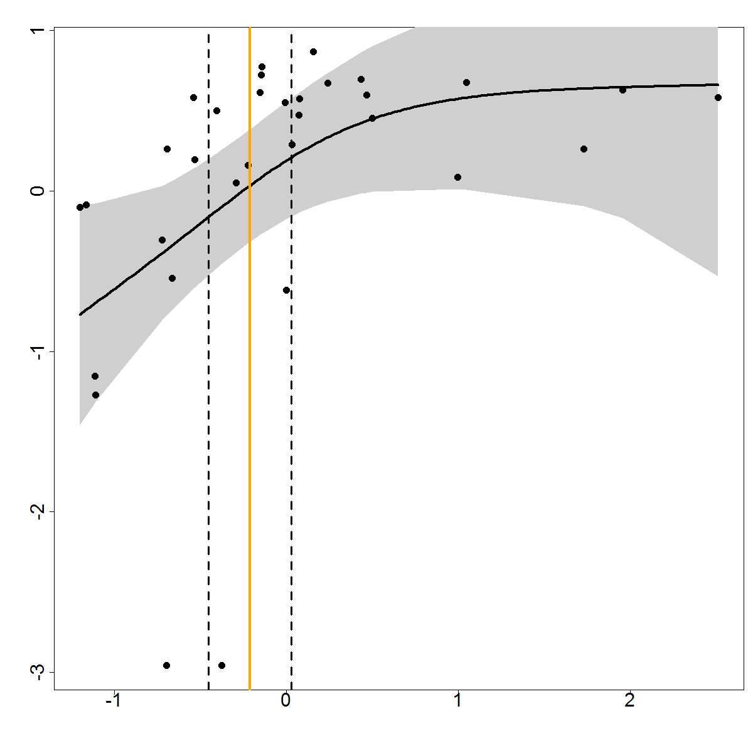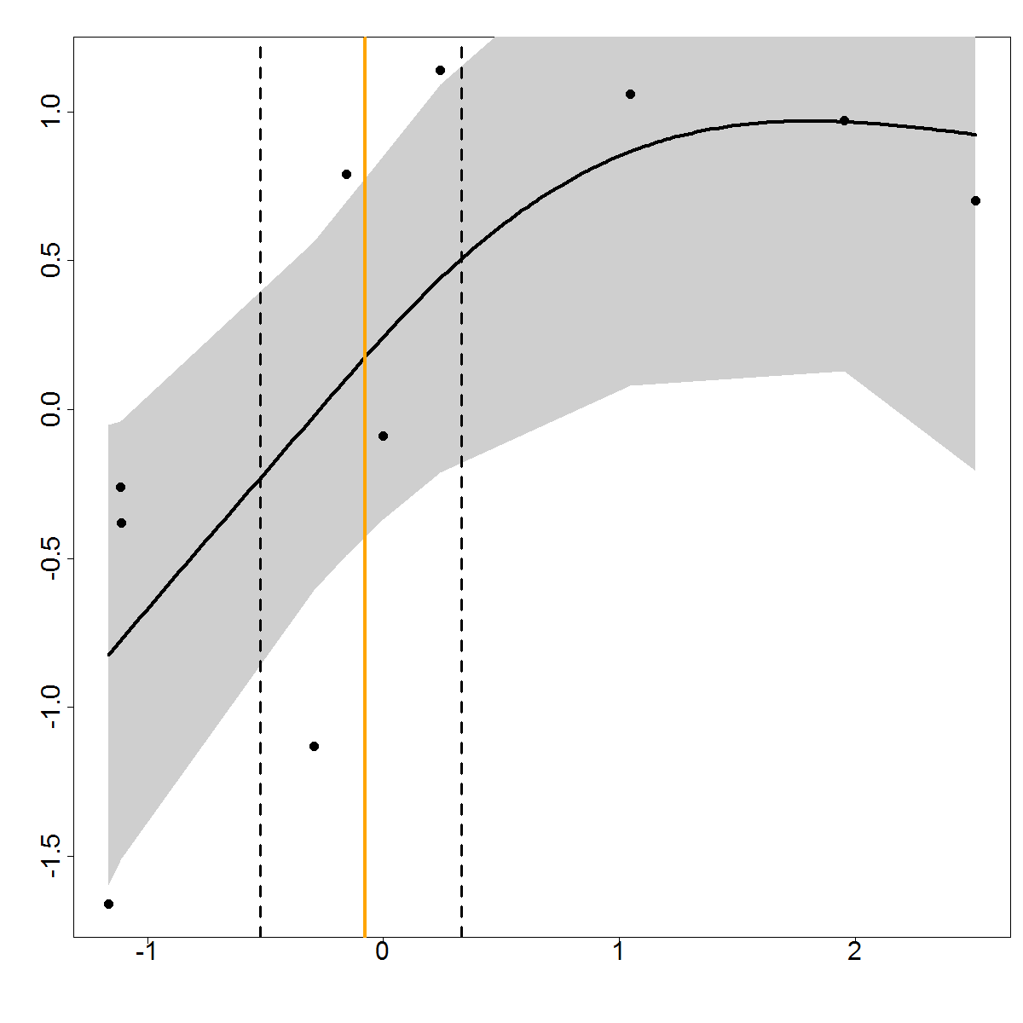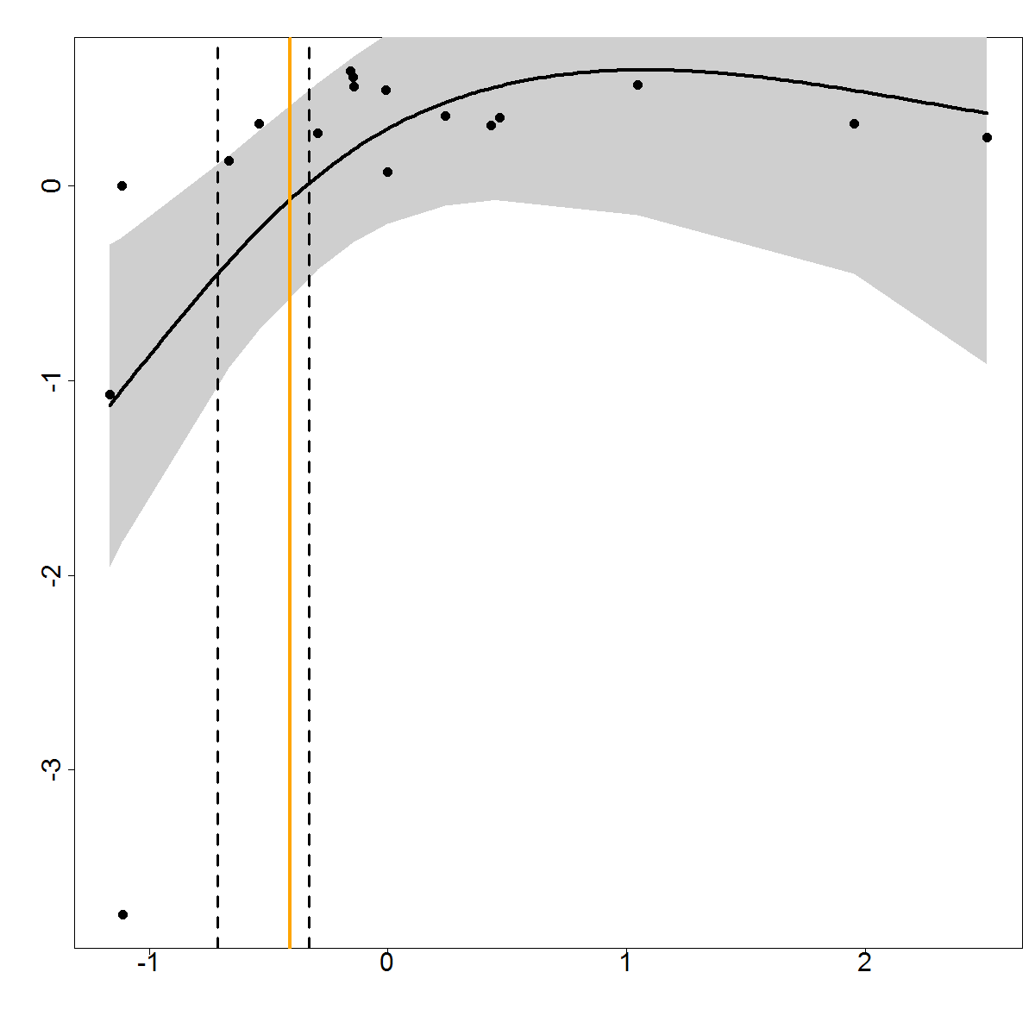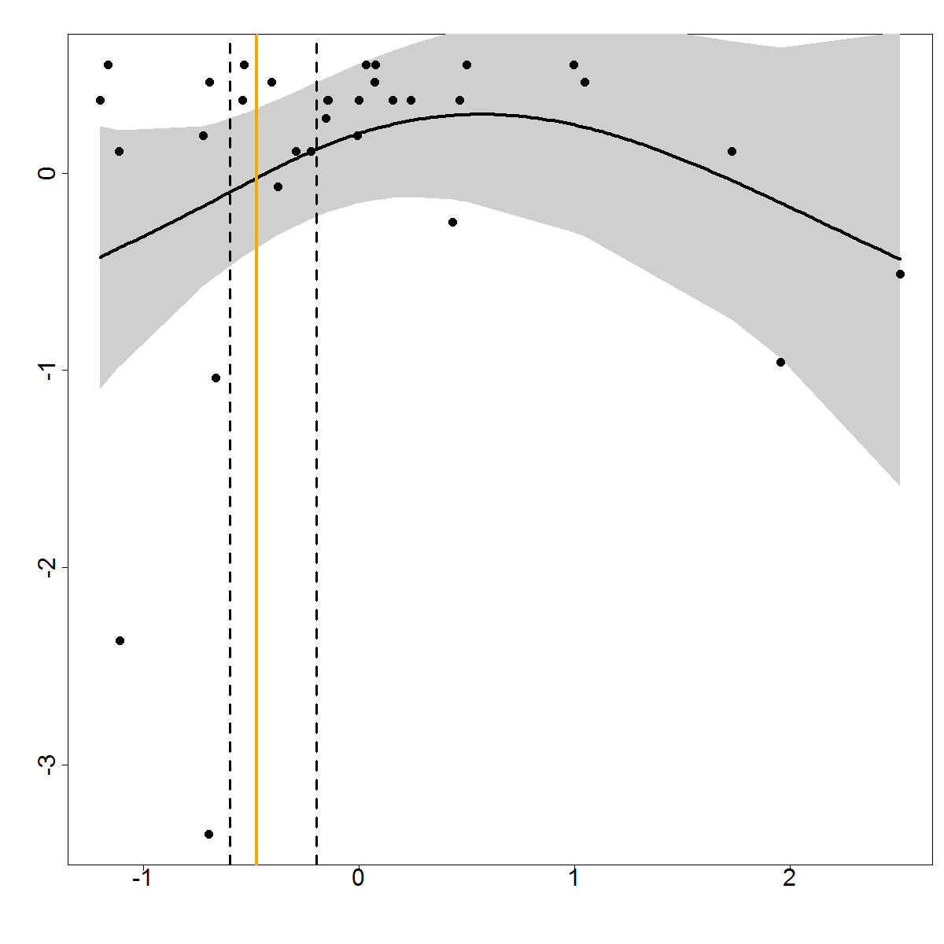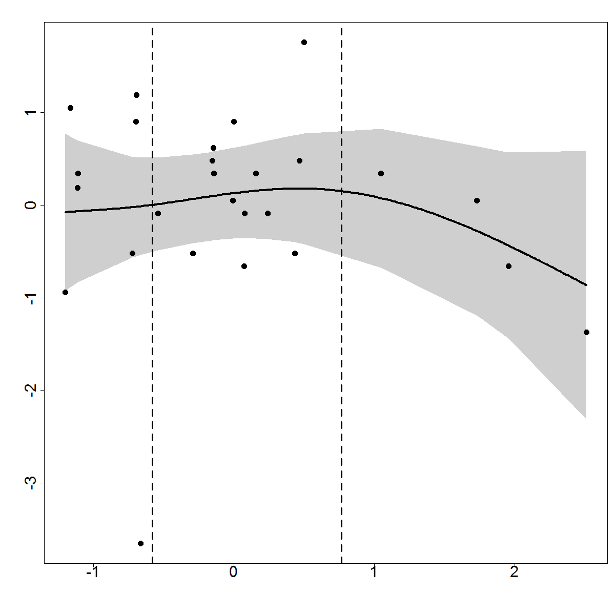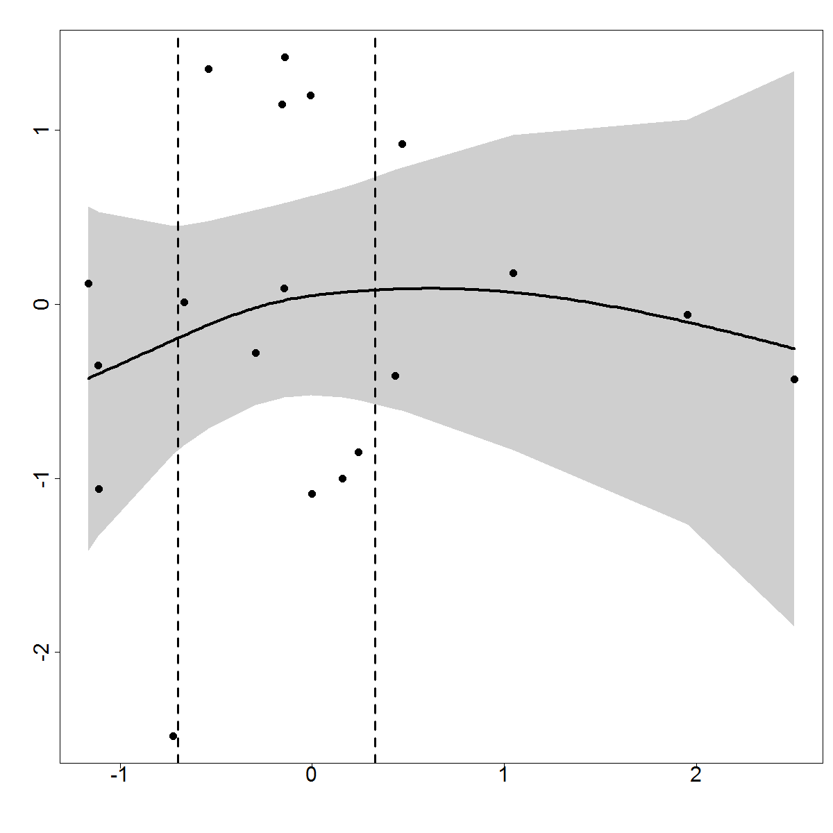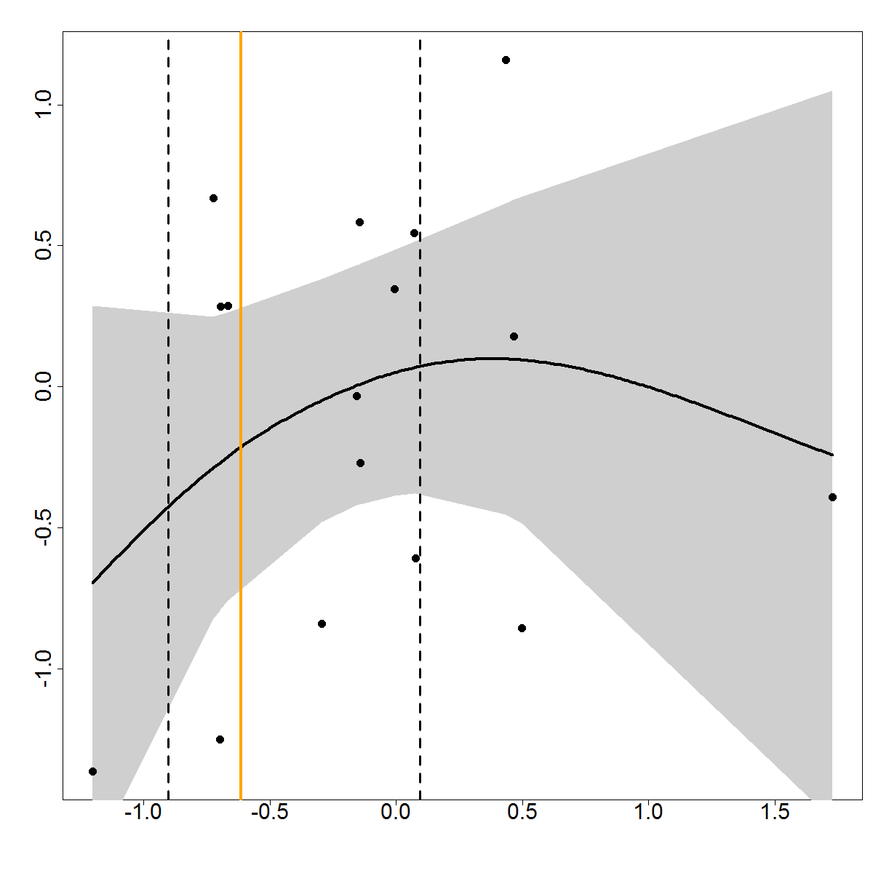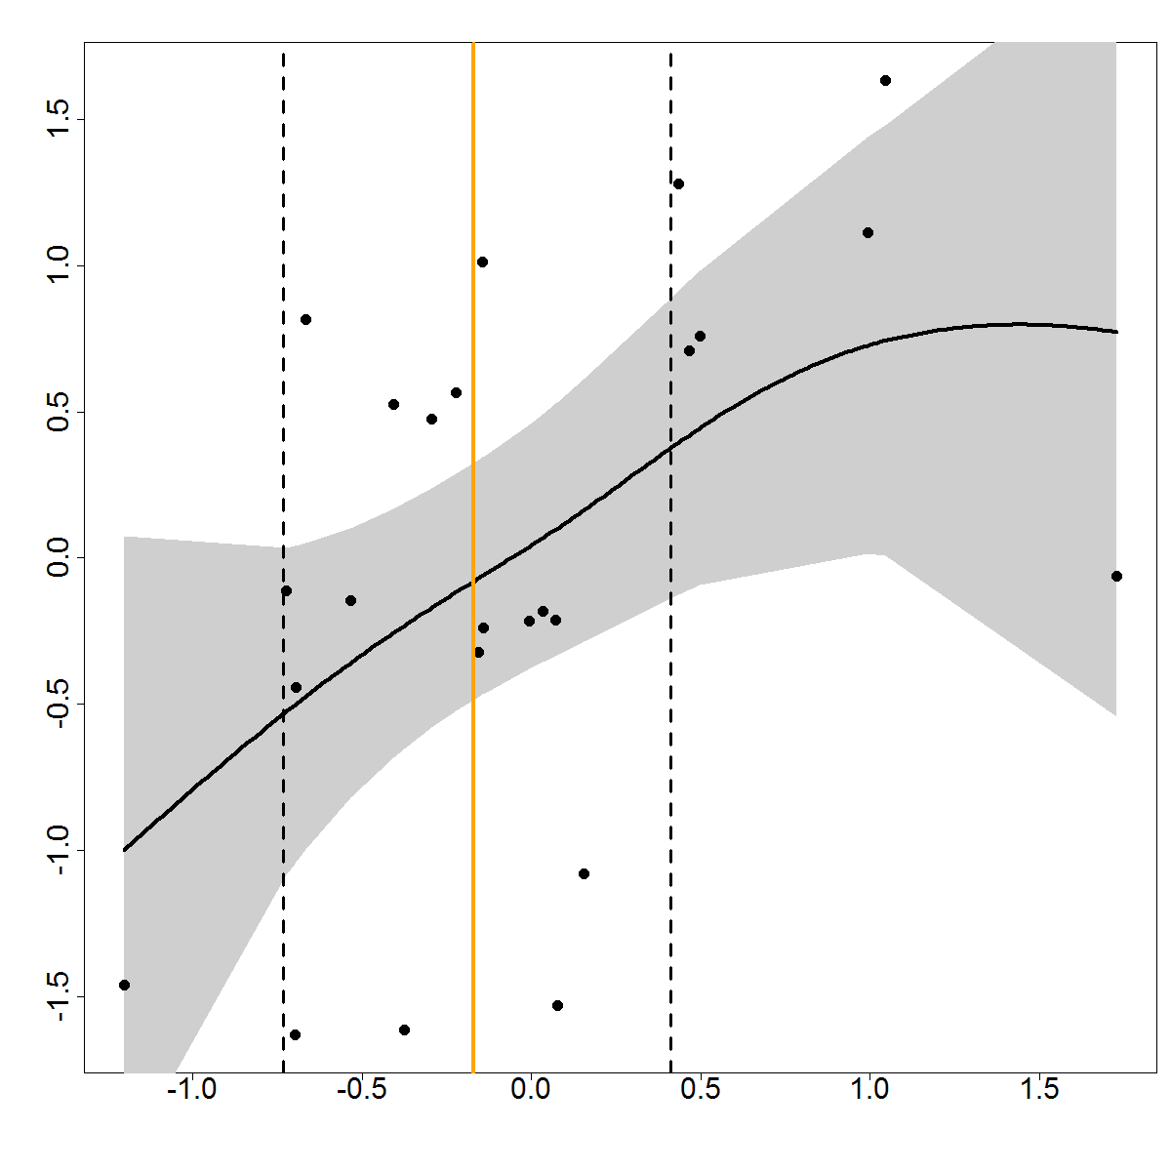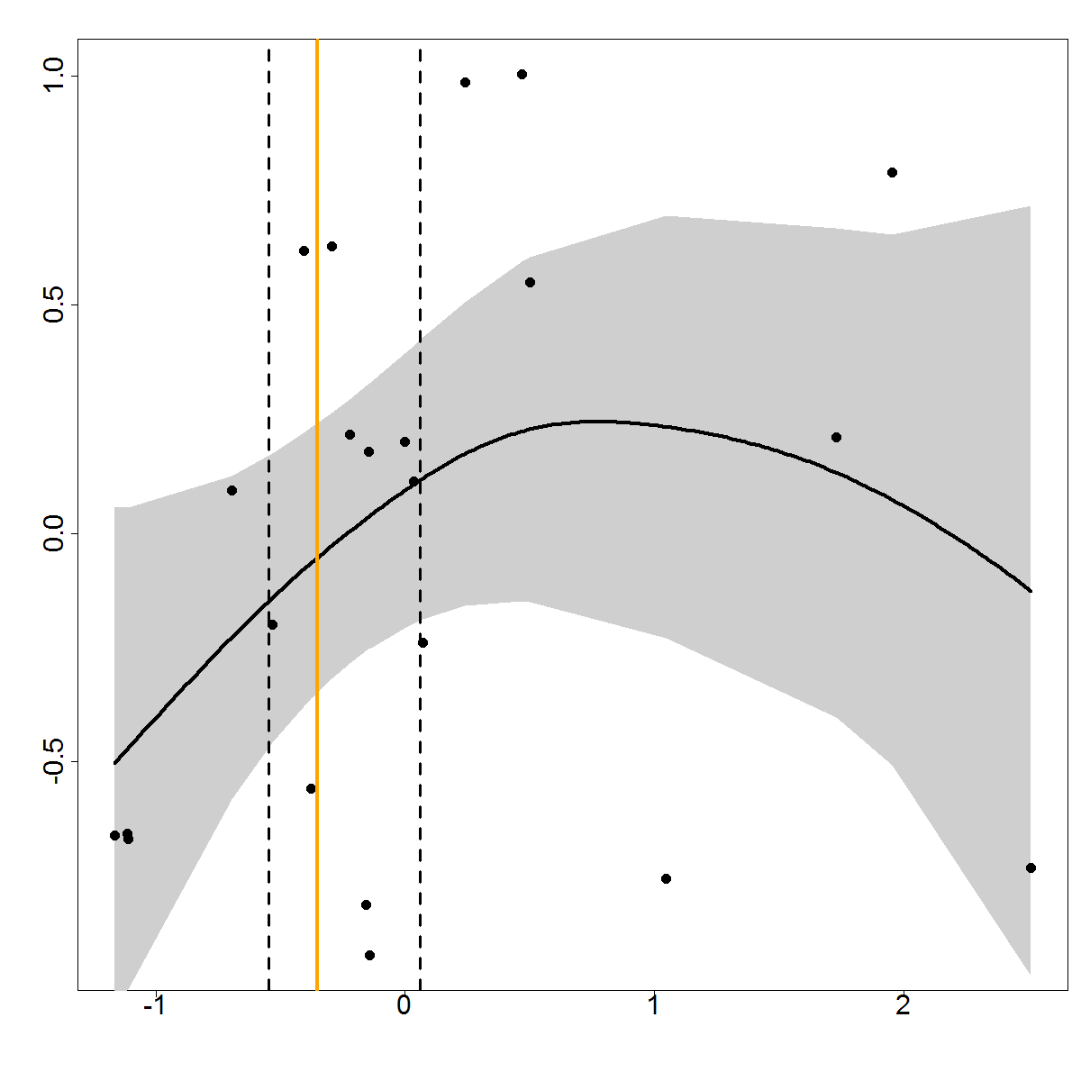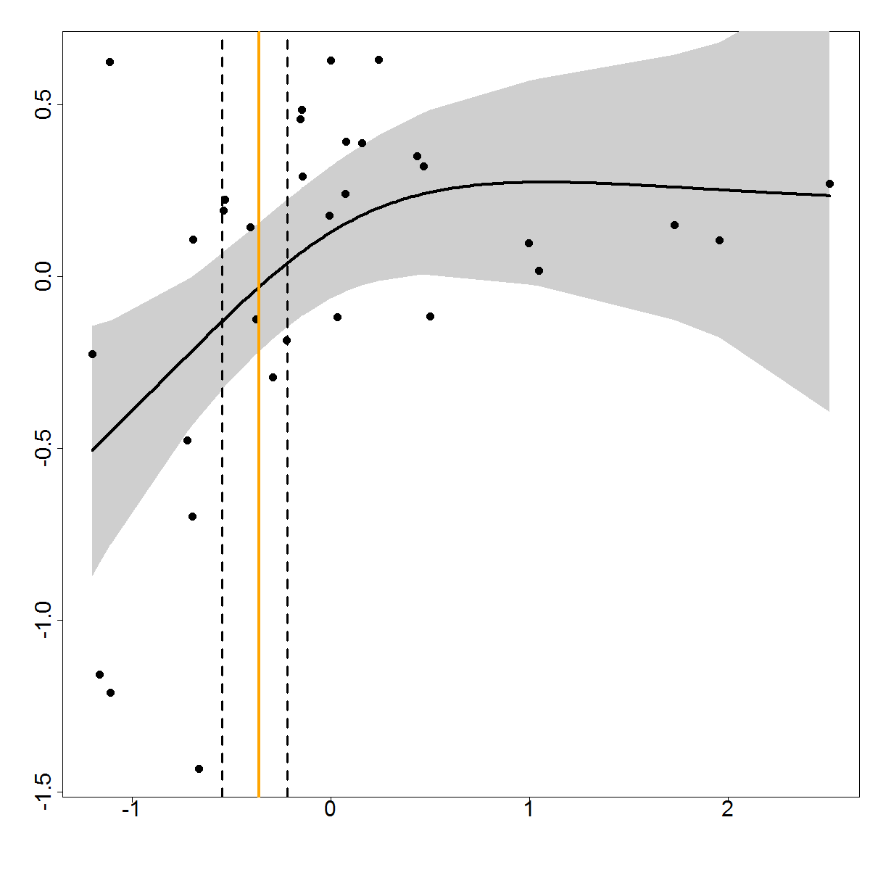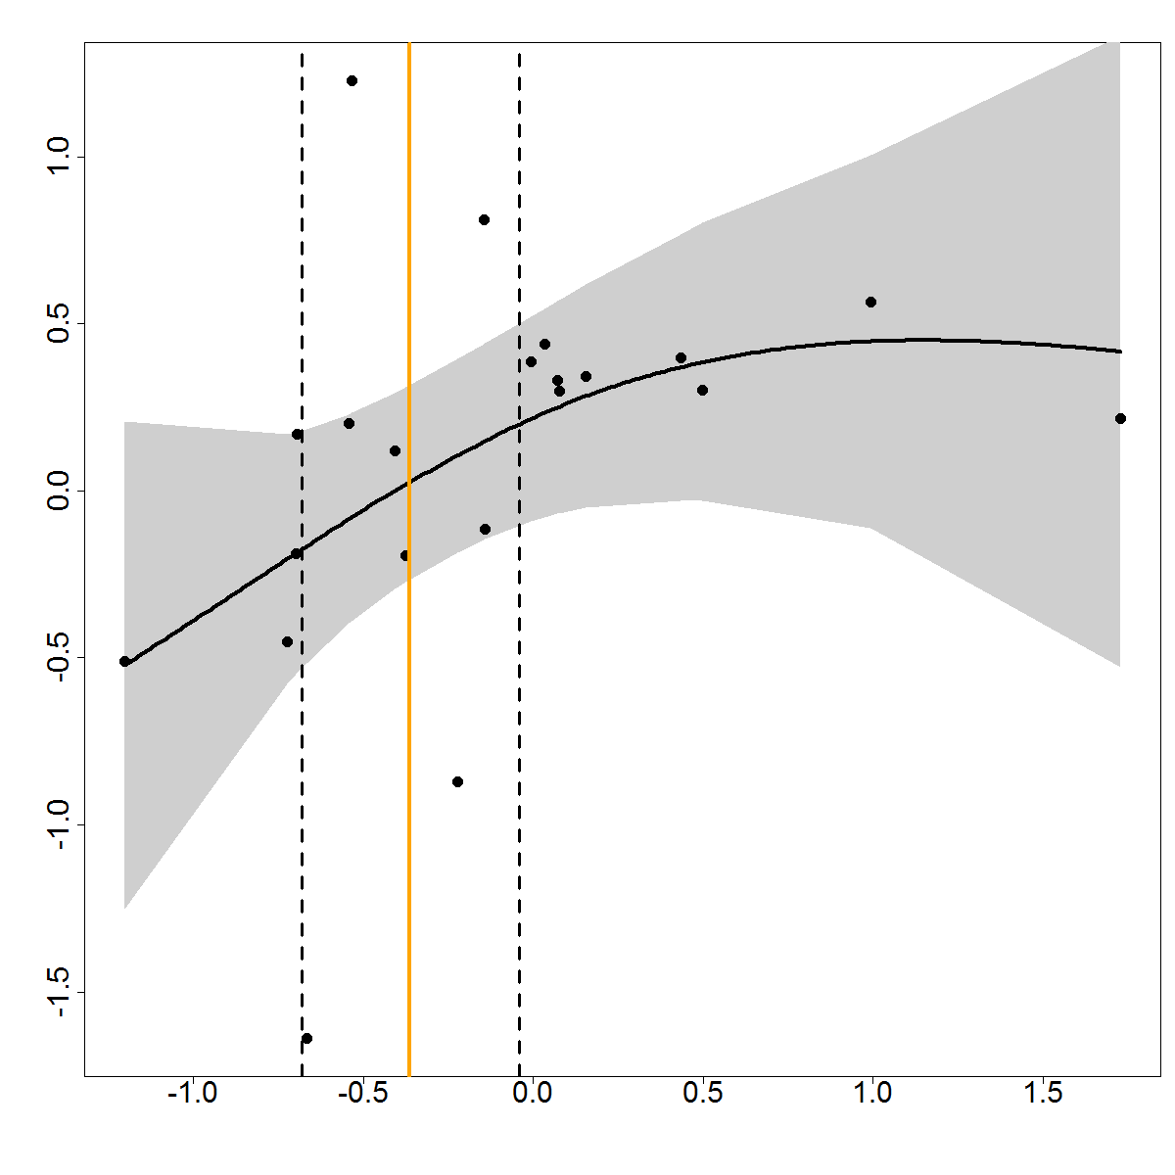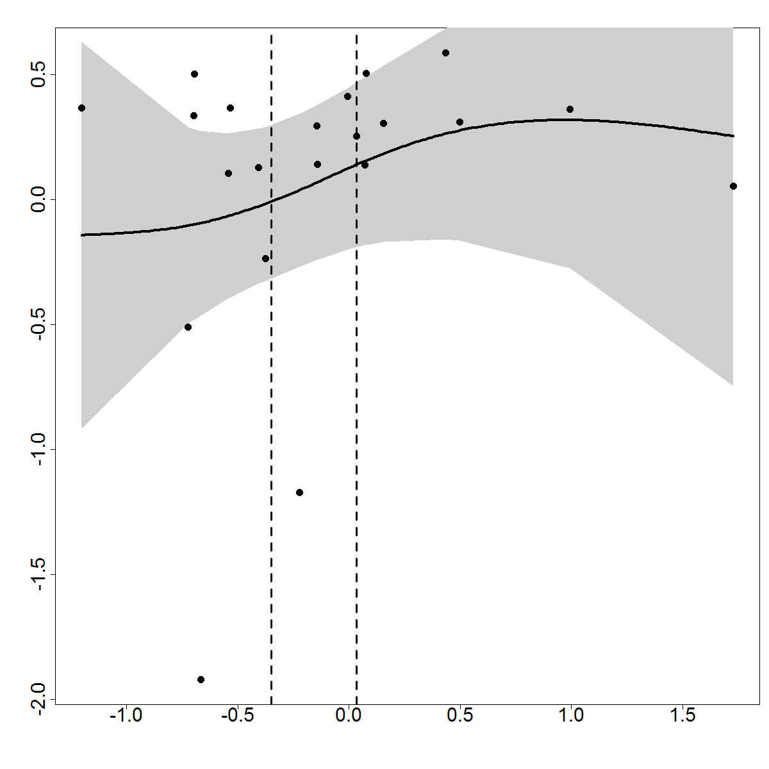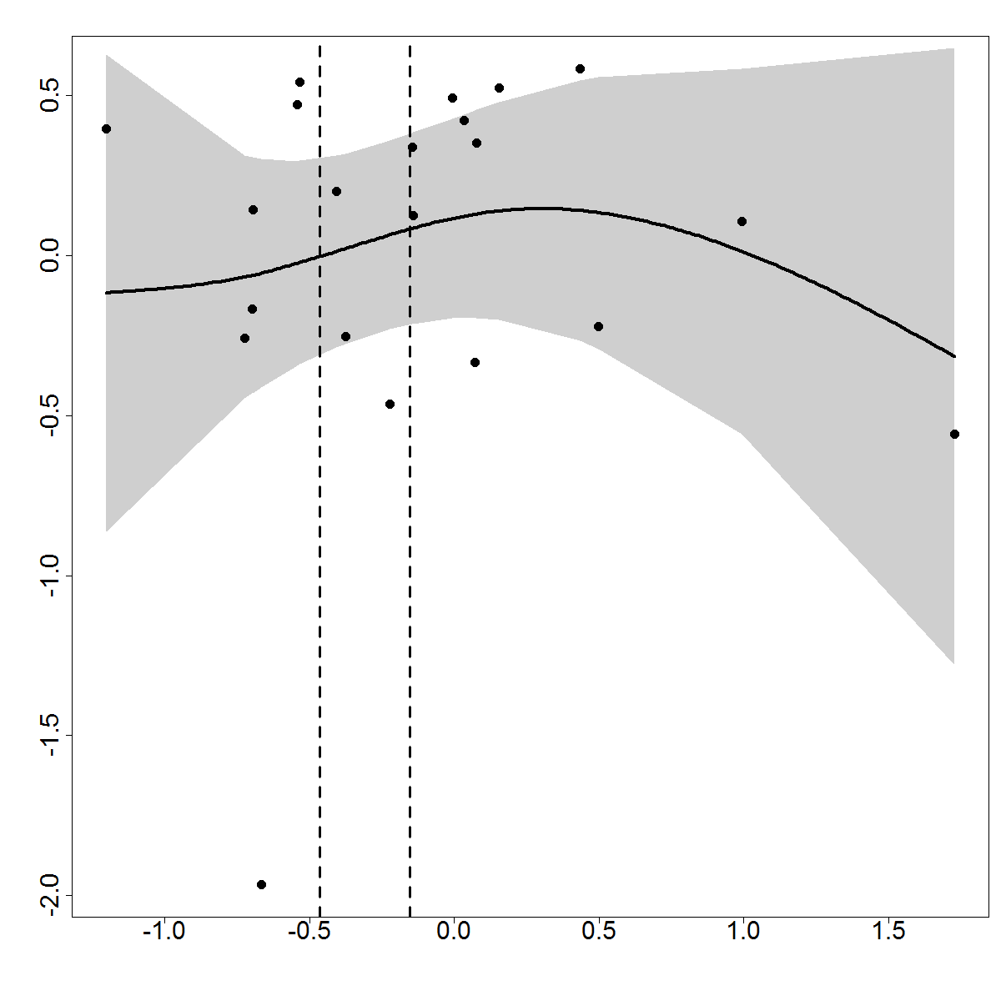

**I**

h

i

j

k

l

m

d

c

g

e

f

b

a

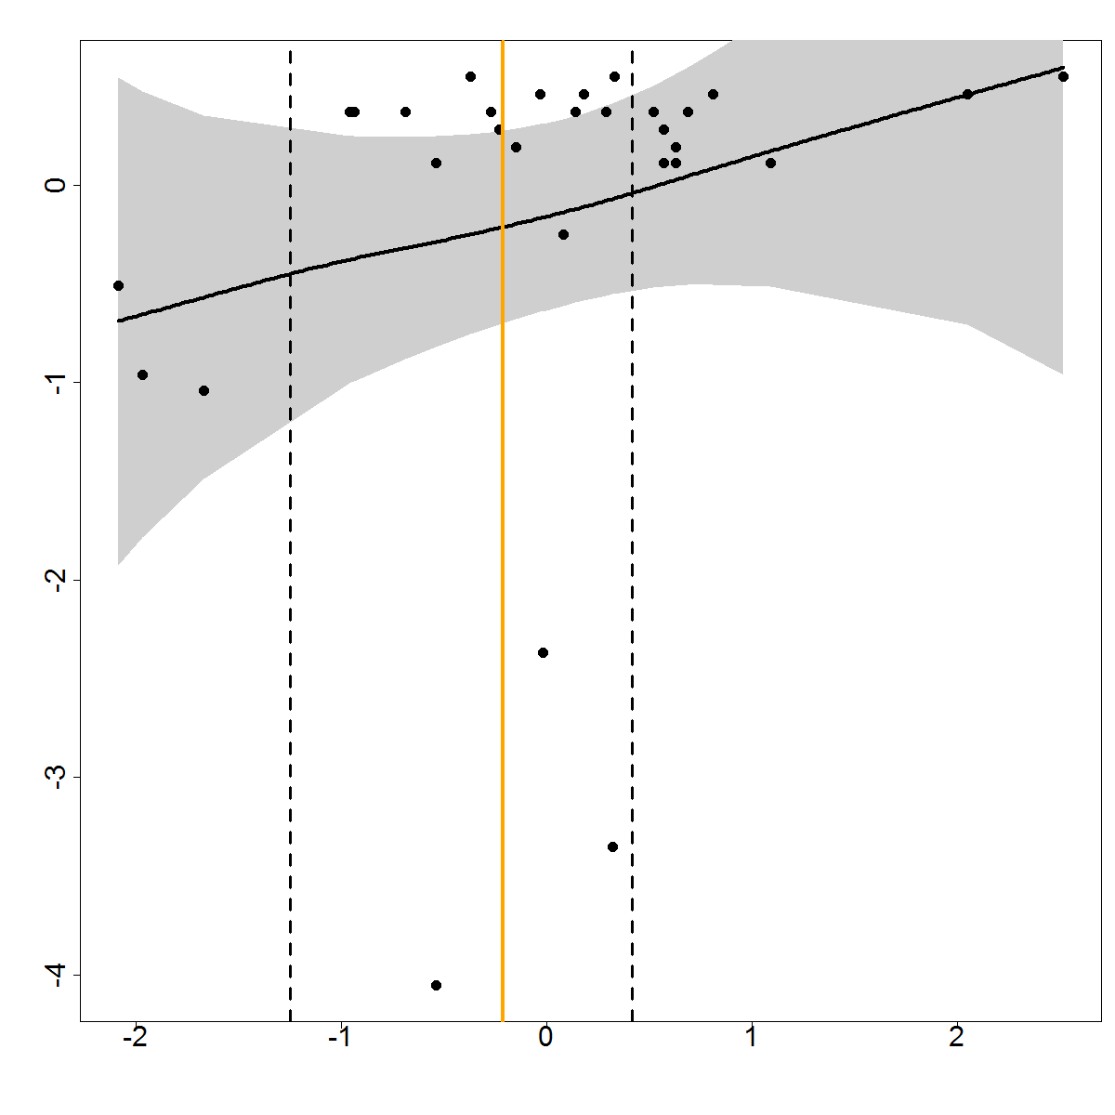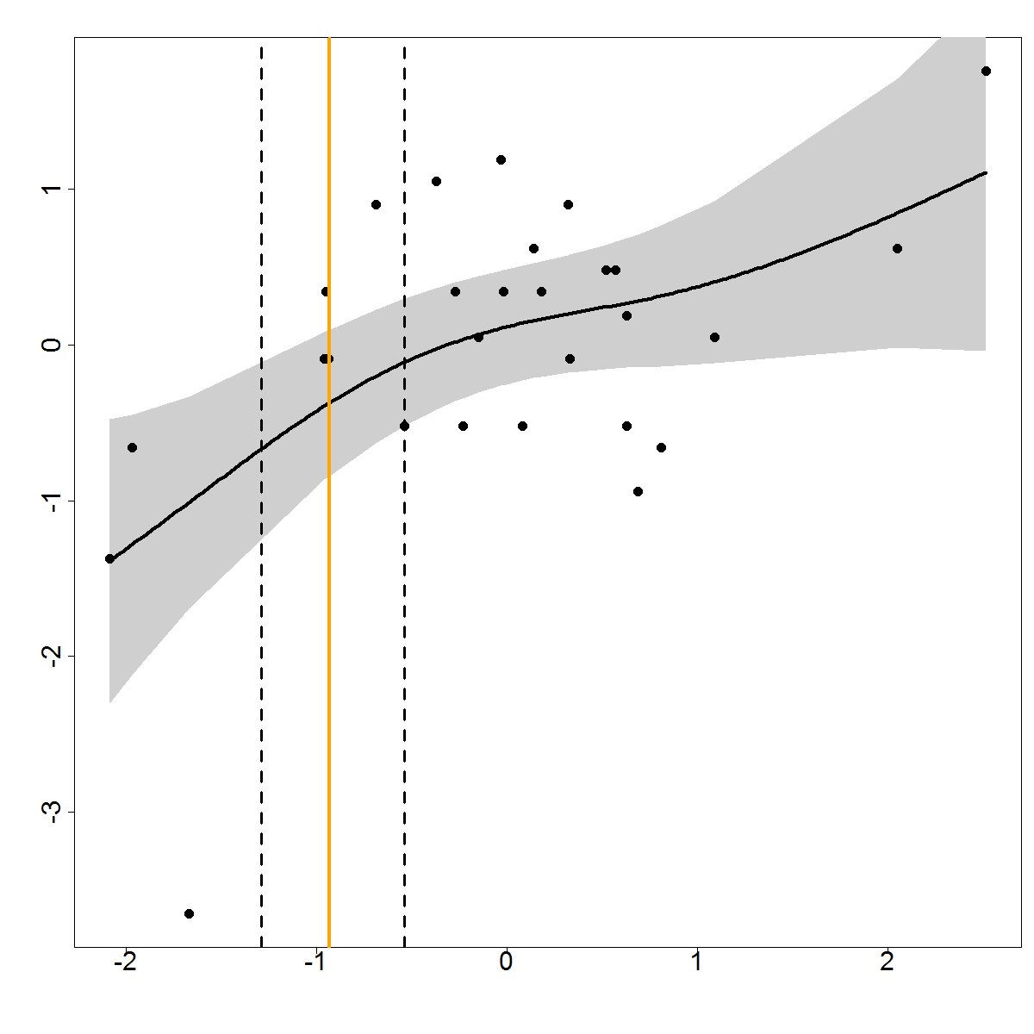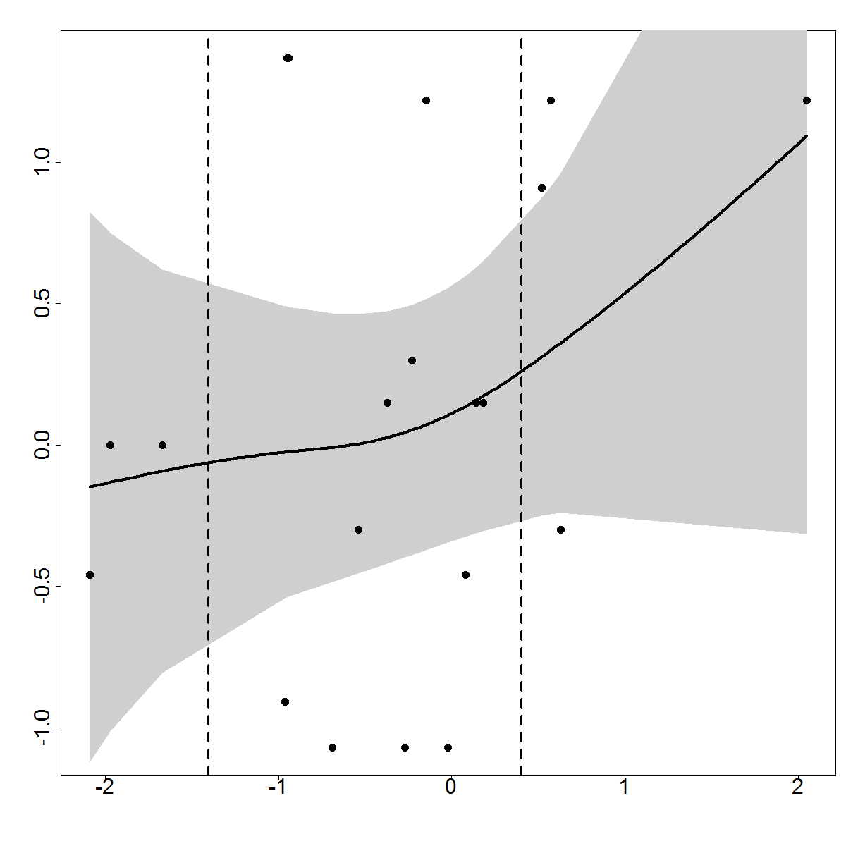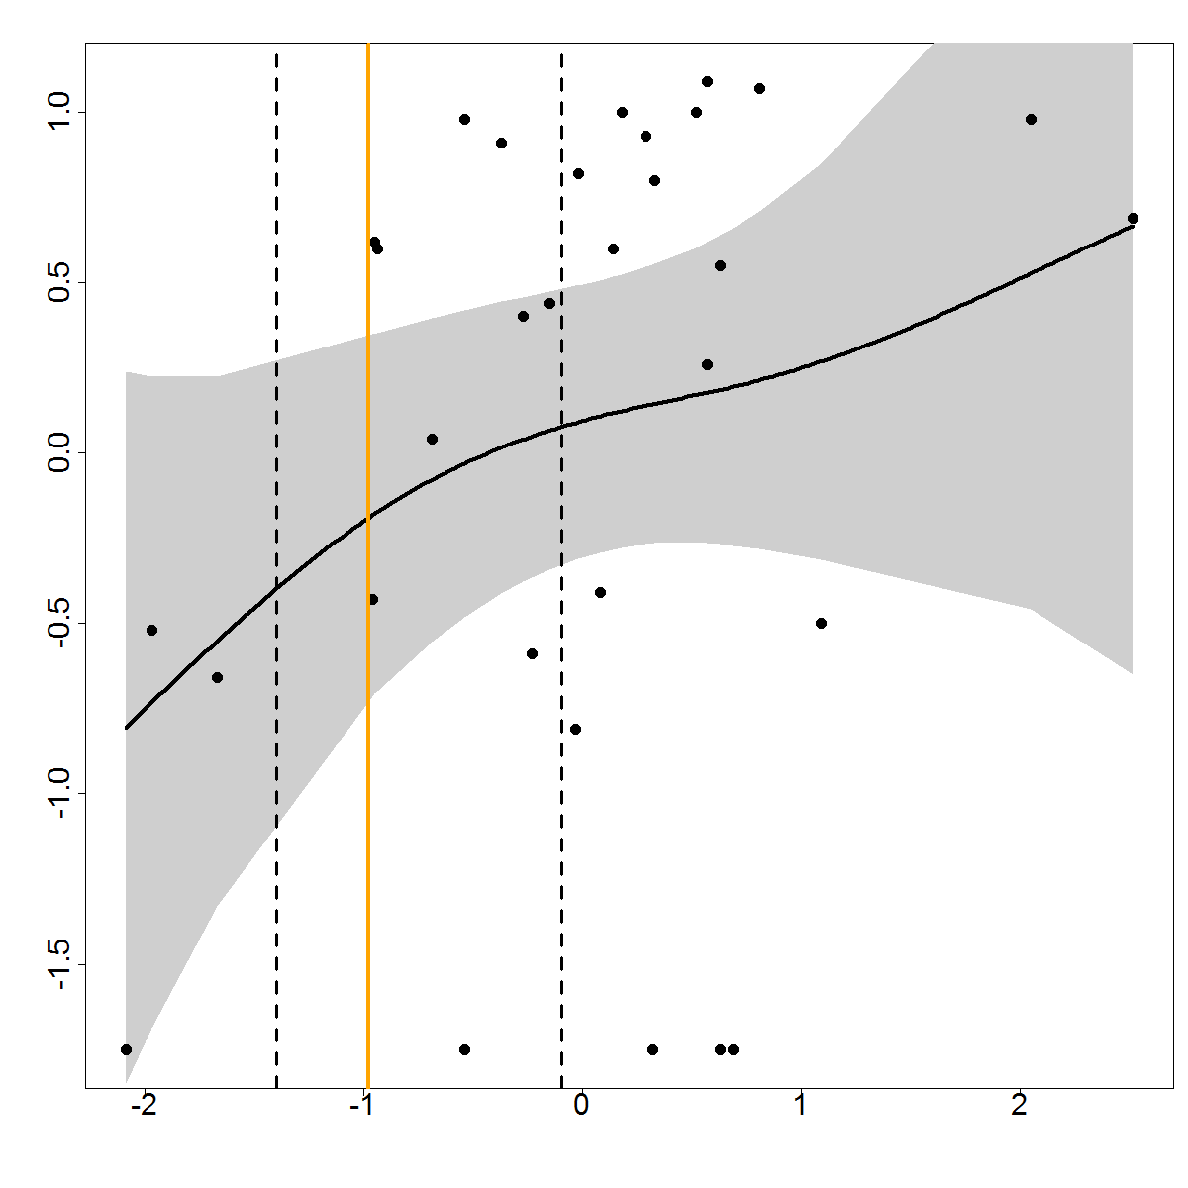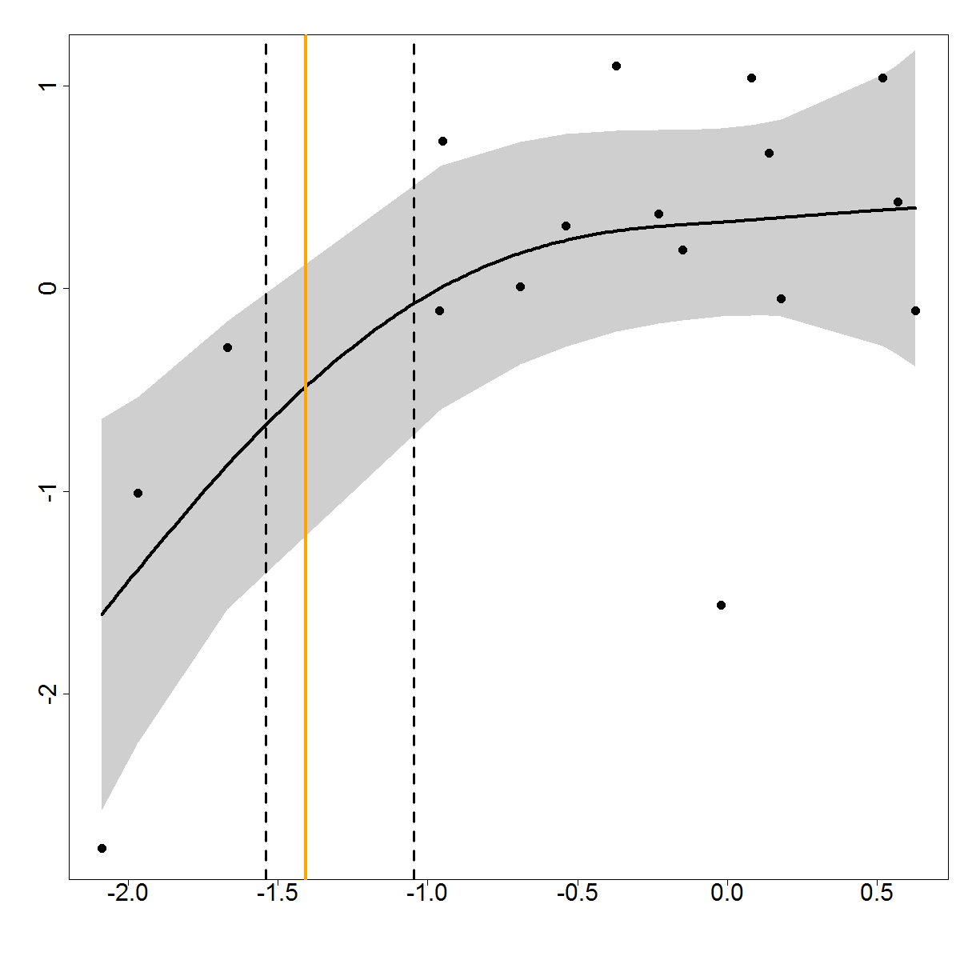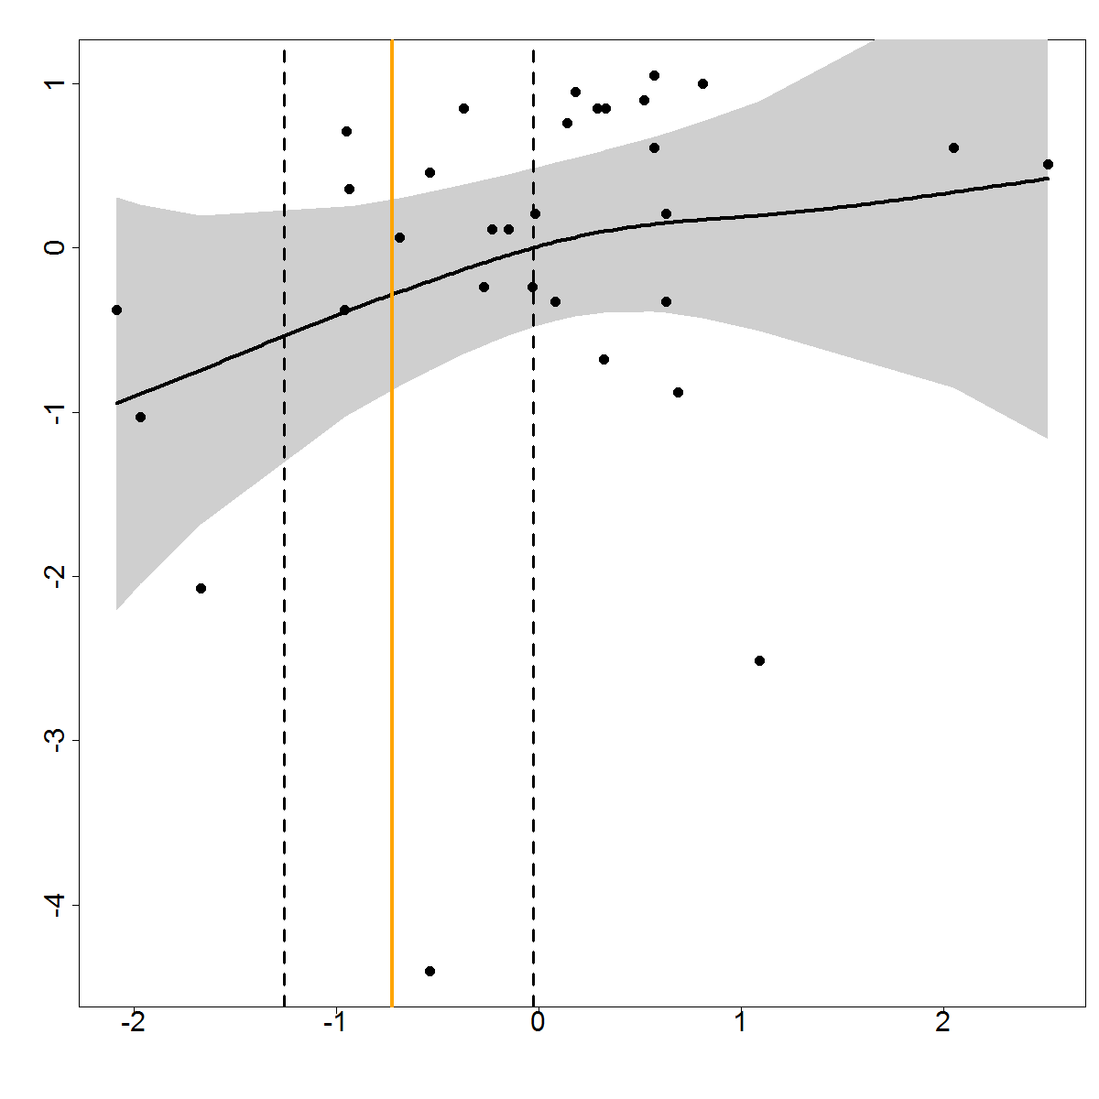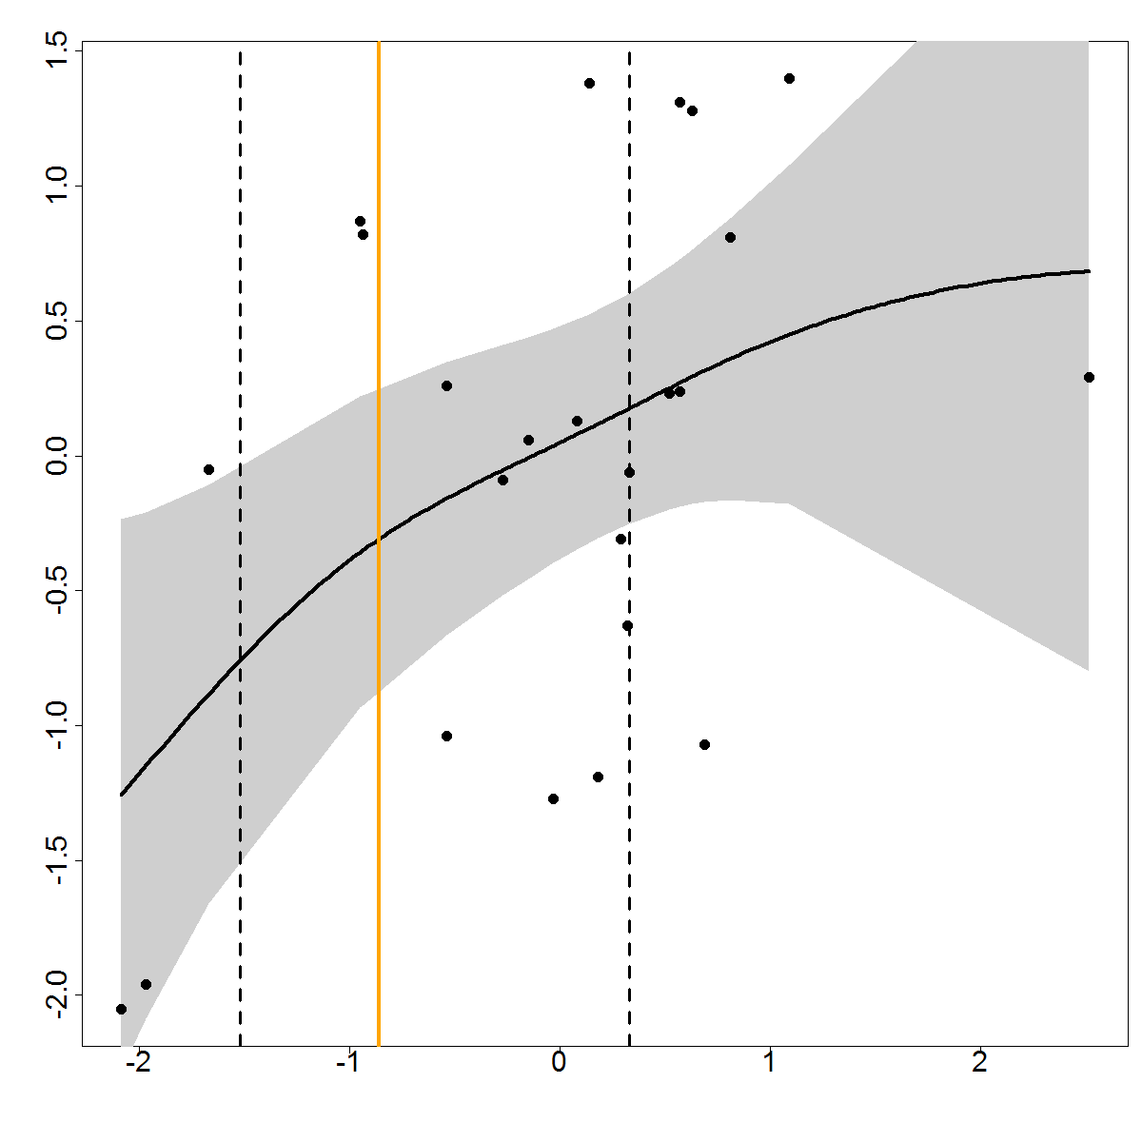

**II**

a

i

f

e

d

c

b

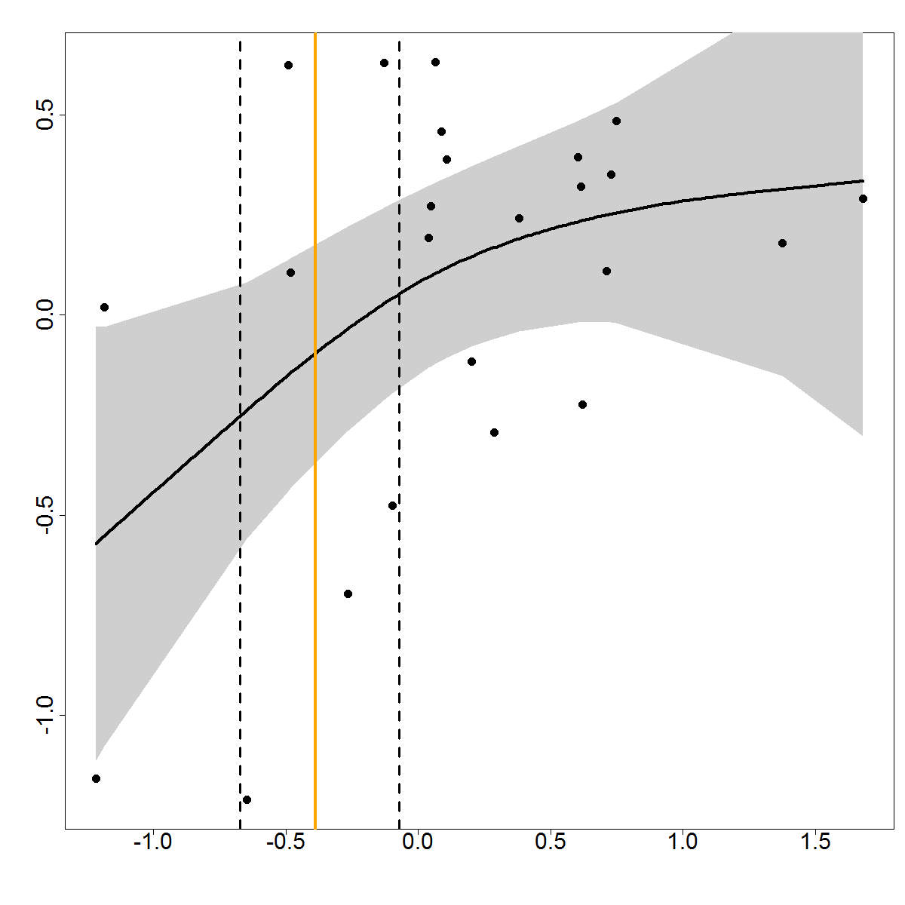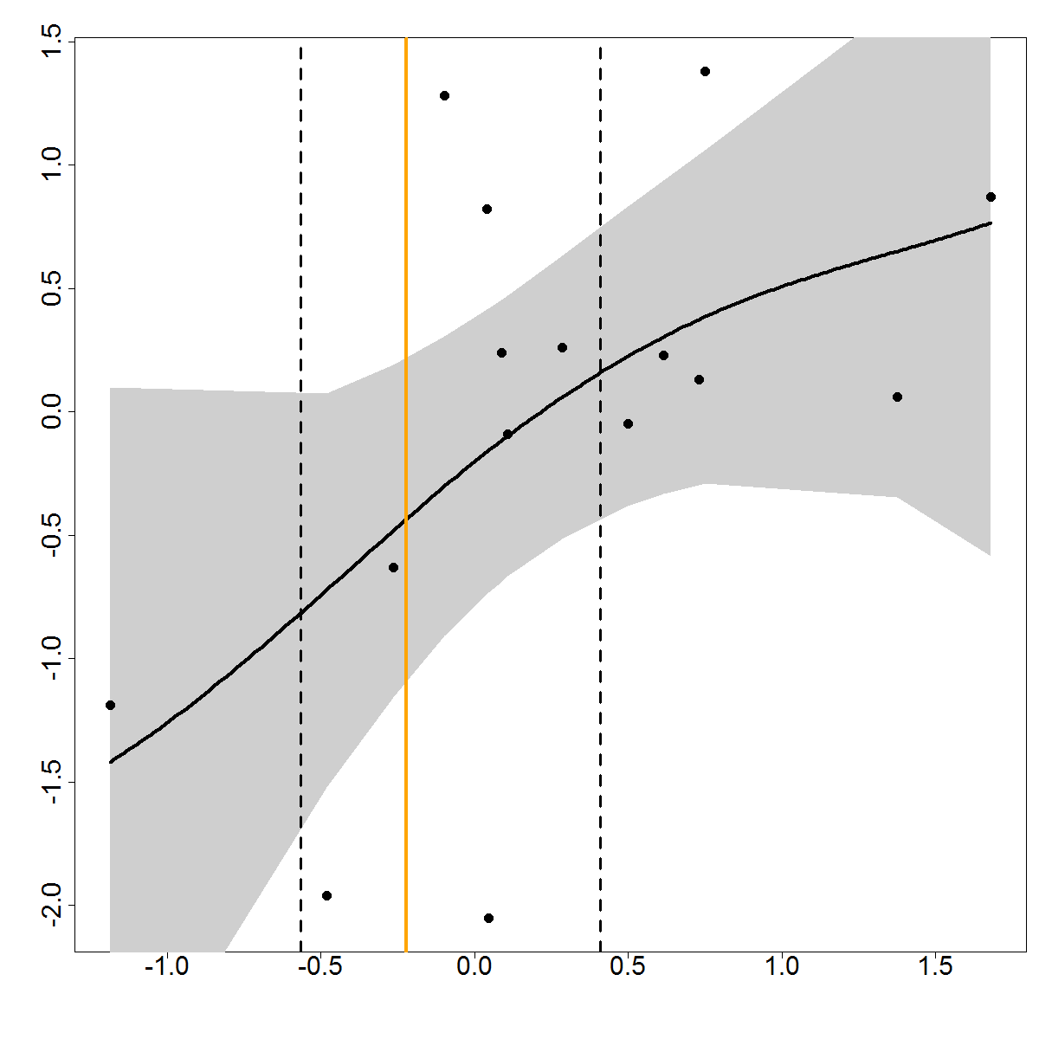

**III**

b

a

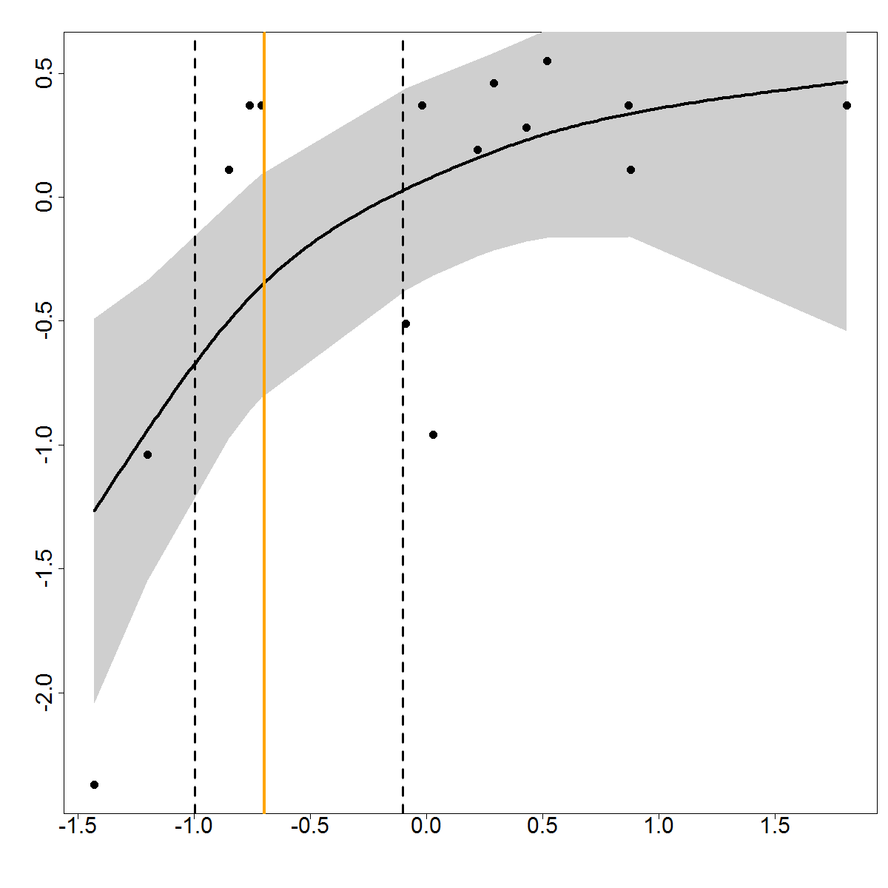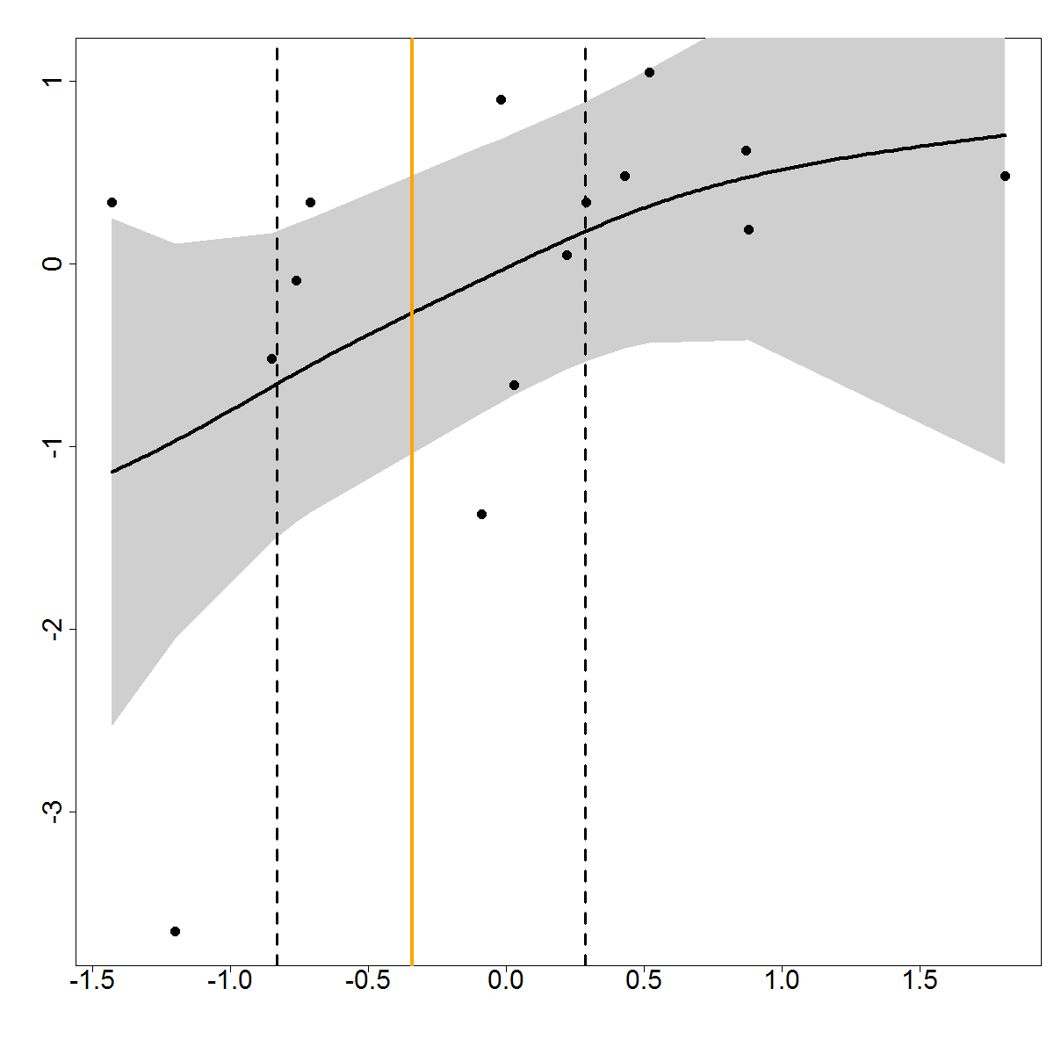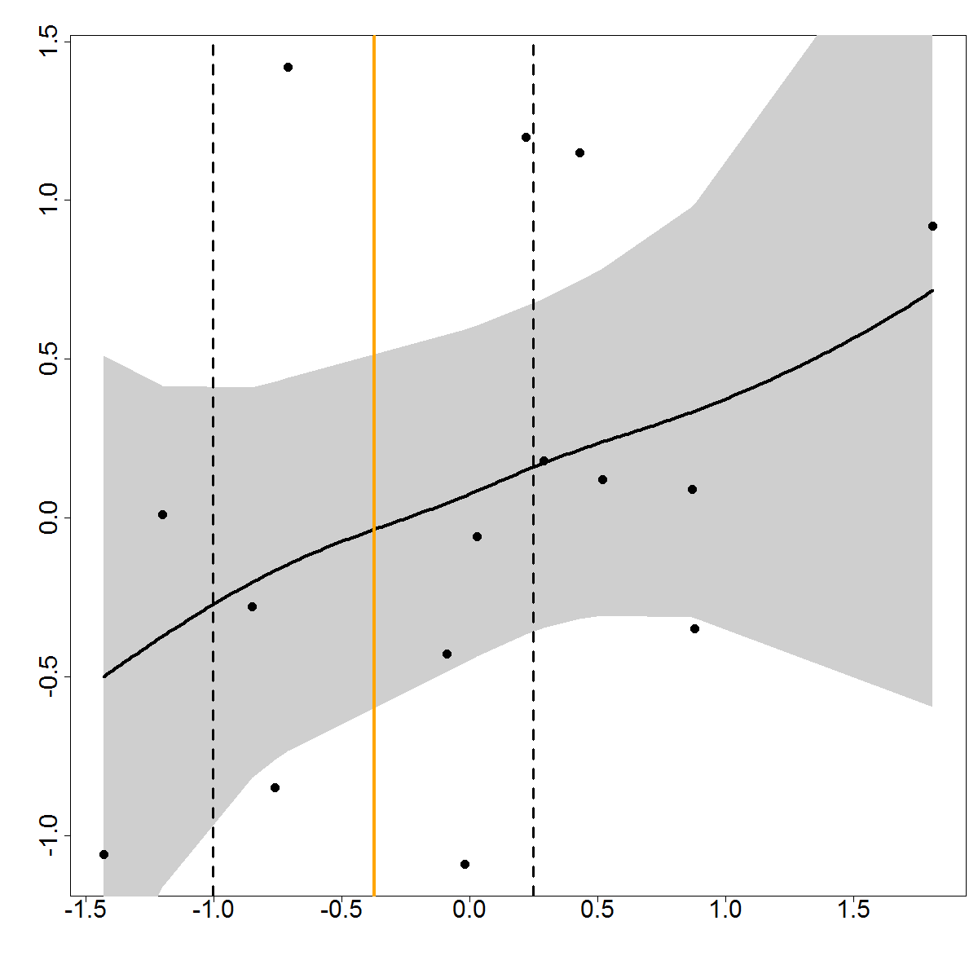

**IV**

d

c

b

a

**Supplemental Material II**

***Northern CCE*.** Appropriate overlap of predator-prey time series was largely lacking for the northern CCE. Cury et al*.* (2011) suggested that at least 13 years of predator-prey data were needed to demonstrate prey thresholds and 11 years of data to determine prey maxima; our study also found no good models with less than 11 years of data. For example, common murre reproductive success at Yaquina Head, Oregon (Gladics et al*.* 2012, Leising et al*.* 2014), and growth indices for three rockfish species derived from otolith rings in northern California and Oregon (Black et al*.* 2005, 2008) were examined but yielded no good threshold models due to the low number of years corresponding to indices of prey (NMFS forage fish surveys off Oregon (R. Emmett and R. Brodeur/NOAA; Emmett and Brodeur 2000, Emmett et al*.* 2005, Brodeur et al*.* 2006, Leising et al*.* 2014).

Available pinniped datasets in this region did not distinguish measures of productivity (e.g., pup counts) and thus could not be used (Jeffries et al. 2003, Brown et al*.* 2005, Lowry et al*.* 2008). Many predatory fish time series off the Oregon and/or Washington coasts included predators of copepods, which did not fit our criteria for mid-trophic forage species (see Szoboszlai et al*.* 2015), and krill, for which we also did not have abundance indices in this region.

We did find relationships of Chinook salmon survival in the northern CCE with anchovy and whitebait smelt (*Allosmerus elongatus*) (threshold -0.24 normalized anchovy value and 54% of maximum anchovy index value; and -0.65 and 48%, respectively, for whitebait smelt), although these models were not very robust with only 11 years of data each. The relatively high thresholds may be a result of poor sample size, or indicate use of alternate prey; indeed, we know that Chinook salmon diet in that region can be quite diverse (Daly et al*.* 2009). Future work includes testing our hypothesis in the northern CCE when both predator and prey time series have accrued additional years of data.

***Modeled predatory fish indices*.** Recruitment data for several iteroparous commercial fish species was obtained from stock assessments, which were modeled rather than observed data. Therefore, these were not included in our main analysis, although results here did support our conclusions. The stock assessments were conducted at the federal level of management and thus not partitioned into regions within the CCE; rather, these data spanned the entire west coast of the U.S. Hake recruitment was modeled against sardine prey, yielding a somewhat lower threshold than was observed for other sardine predators, although similar to overall thresholds observed in the CCE (Table S3; Fig. S2a,b). Albacore recruitment was compared against anchovy prey. While separate models did not converge to yield thresholds (Table S3; Figure S2c), approximate confidence intervals around the change points of each function were similar to those of marine birds and mammals that exhibited clear relationships with anchovy (lower 22% to upper 50% for albacore; 17 – 34% for marine birds and mammals). The lack of a clear single-prey threshold here was likely influenced by alternate prey usage in this highly migratory predator. Additionally, Glaser et al. (2015) suggested that the northern CCS is a more significant source of prey for albacore, while we modeled prey in the central to southern CCS in this study.

**Table S3.** Prey thresholds of predatory fish recruitment versus overall predator thresholds including productivity of all other predators. *Predator indices: Observed reproductive success or young fledged per breeding pair = RS, Peak pup count = Pup, Survival of ocean period salmon = Returns; Modeled recruitment = Recruit. See text for location definitions.*

|  |  |  |  |  |  |  |  |  |  |  |
| --- | --- | --- | --- | --- | --- | --- | --- | --- | --- | --- |
| **Predator** | **Prey** | **Region** | **Specific location** | **Predator index** | **N pred. spp.** | **N colonies/ subpops** | **Prey threshold** | **Years modeled** | **N spp -yrs** | |
| Hake | Sardine | U.S. west coast | CA, OR, WA | Recruit | 1 | 1 | (-0.54) **23%** | 1992-2011 | | 24 |
| Seabird, sea lion, fish (incl. hake) | Sardine | central CA | SBI, ANA, SMI, SCI, SNI, CV, coastal | RS, Pup, Survival, Recruit | 4 | 8 | (-0.28) **32%** | 1992-2011 | | 103 |
| Albacore | Anchovy | U.S. west coast | CA, OR, WA | Recruit | 1 | 1 | no threshold* | 1966-2011 | | 36 |
| Seabird, sea lion, fish (incl. albacore) | Anchovy | CA | SFI, ANI, ALZ, SBI, ANA, VB, SMI, SCI, SNI, coastal | RS, Pup, Recruit | 7 | 10 | (-0.33) **27%** | 1966-2011 | | 328 |

*\* Where there were sufficient observations but the model did not converge to calculate a threshold, data in the upper left quadrant of curve, when prey abundance was high yet predator productivity was low, signaled alternate prey use precluding a significant relationship with just one prey species.*

**Figure S2**. Models of predatory fish indices of recruitment against forage species: a) U.S. West Coast hake and sardine prey and b) CCE predators on sardine, including hake; c) U.S. West Coast albacore and anchovy prey and d) CCE predators on anchovy, including albacore.

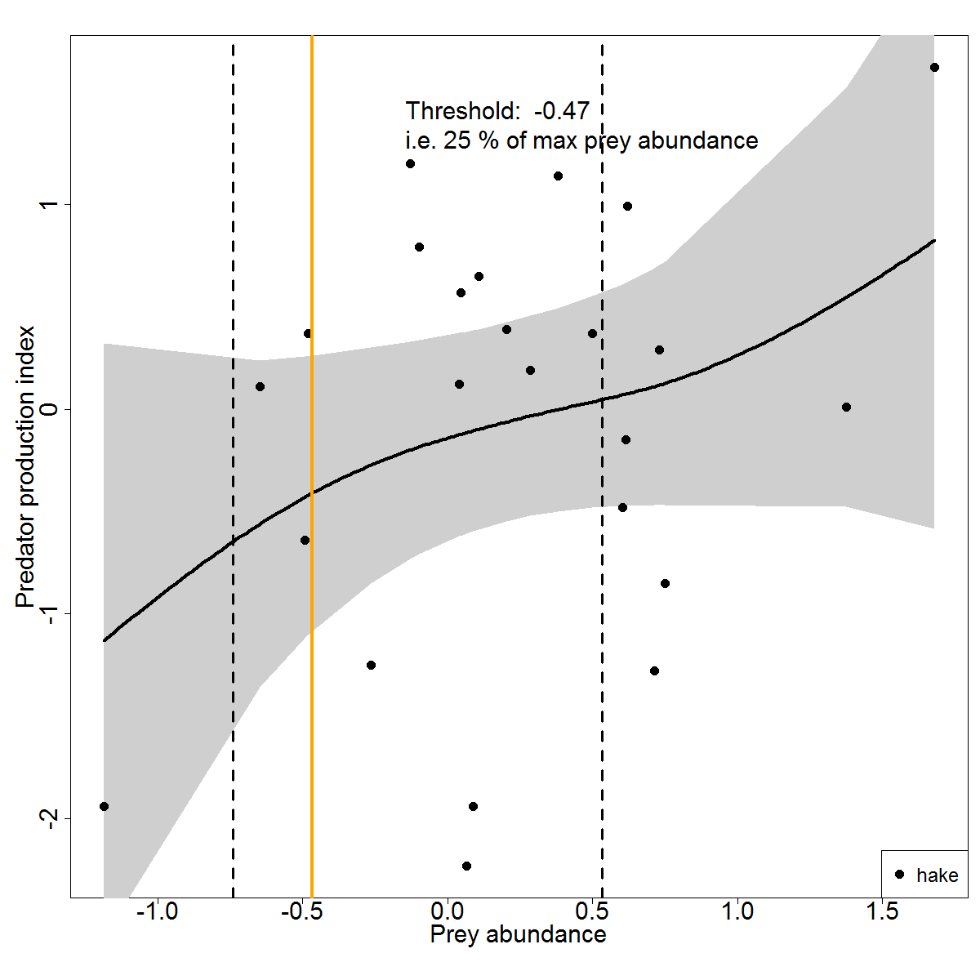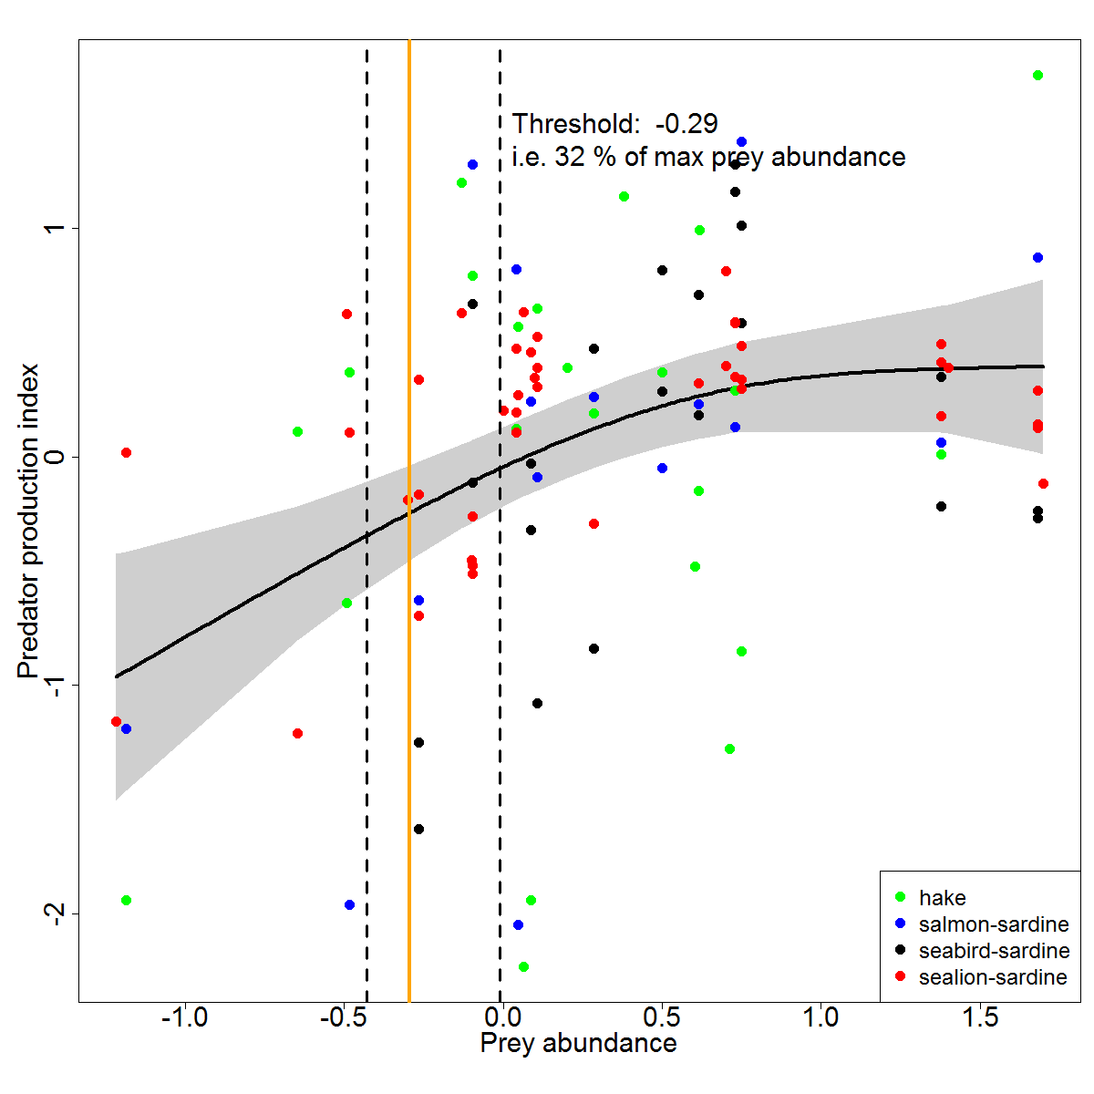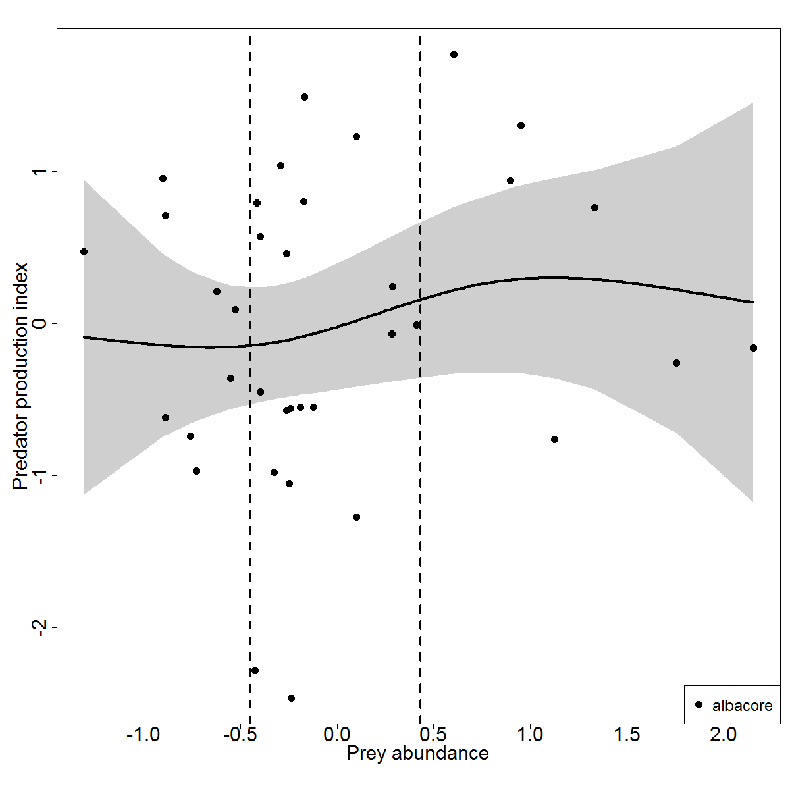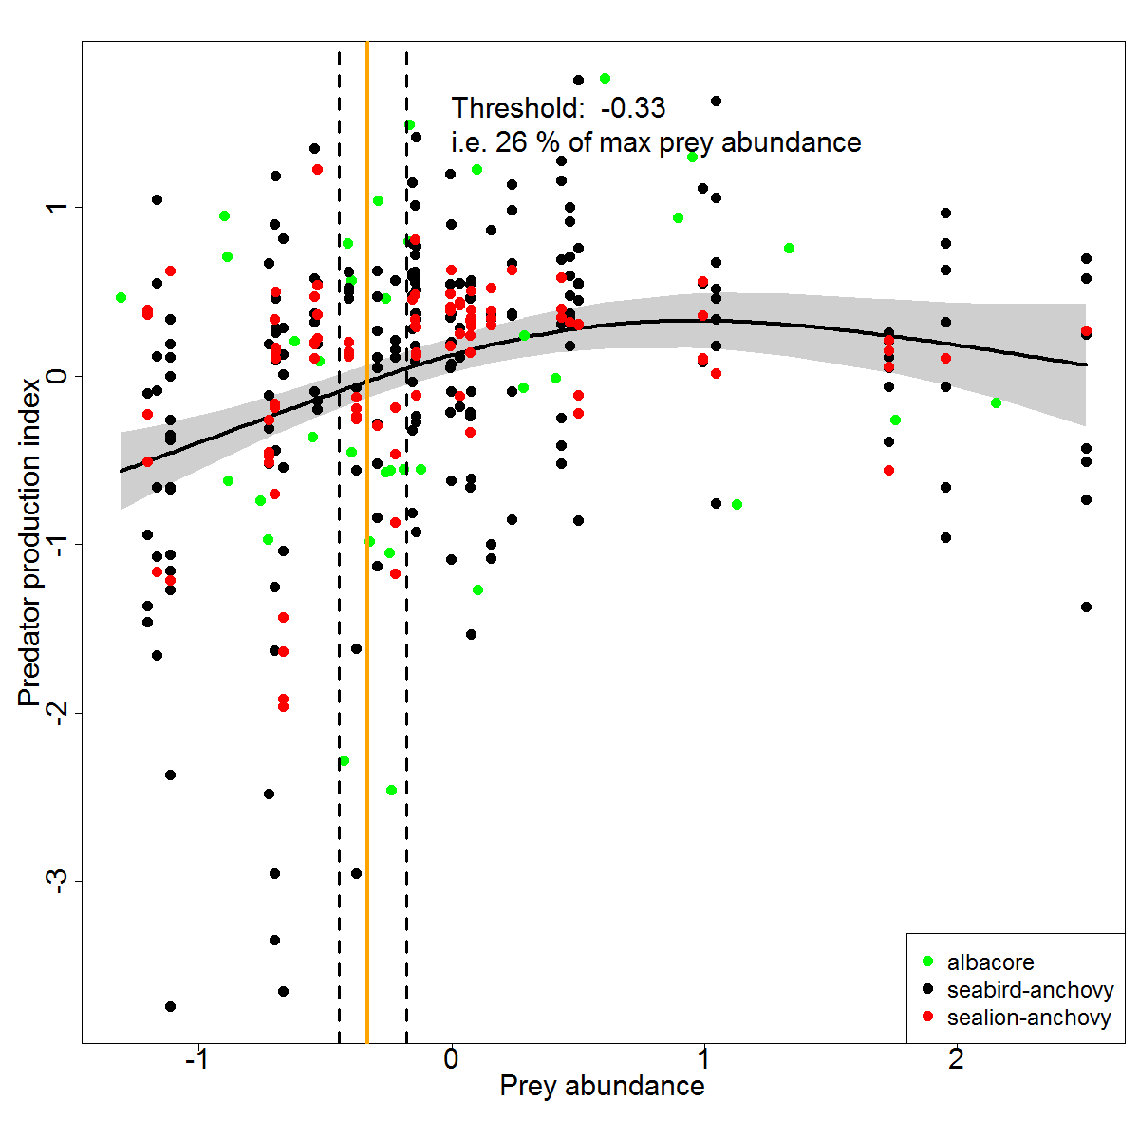

**Supplemental Material Literature Cited.**

Ainley, D. G., D. W. Anderson, and P. R. Kelly. 1981. Feeding ecology of marine cormorants in southwestern North America. Condor 83:120-131.

Antonelis, G. A., B. S. Stewart, and W. F. Perryman. 1990. Foraging characteristics of female northern fur seals (*Callorhinus ursinus*) and California sea lions (*Zalophus californianus*). Canadian Journal of Zoology 68:150-158.

Atwood, J. L., and P. R. Kelly. 1984. Fish dropped on breeding colonies as indicators of Least Tern food habits. The Wilson Bulletin 96:34-47.

Black, B. A., G. W. Boehlert, and M. M. Yoklavich. 2005. Using tree-ring crossdating techniques to validate annual growth increments in long-lived fishes. Canadian Journal of Fisheries and Aquatic Sciences 62:2277–2284.

Black, B. A., G. W. Boehlert, and M. M. Yoklavich. 2008. A tree-ring approach to establishing climate–growth relationships for yelloweye rockfish in the Northeast Pacific. Fisheries Oceanography 5:368-379.

Brodeur, R. D., S. Ralston, R. L. Emmett, M. Trudel, T. D. Auth, and A. J. Phillips. 2006. Anomalous pelagic nekton abundance, distribution, and apparent recruitment in the northern California Current in 2004 and 2005. Geophysical Research Letters 33:L22S08.

Brown, R. F., B. E. Wright, S. D. Riemer, and J. Laake. 2005. Trends in abundance and current status of harbor seals in Oregon : 1977-2003. Marine Mammal Science 21:657-670.

Burkett, E. E., R. J. Logsdon, and K. M. Fien. 2007. Report to the California Fish and Game Commission: Status Review of California Brown Pelican (*Pelicanus occidentalis californicus*) in California. California Department of Fish and Game Nongame Wildlife Program Report 2007-04. https://nrm.dfg.ca.gov/FileHandler.ashx?DocumentID=83830.

Burton, R. K., and S. B. Terrill. 2012. Least tern literature review and study plan development. H.T. Harvey & Associates/U.S. Army Corps of Engineers Report. http://www.spn.usace.army.mil/Portals/68/docs/Dredging/LMTS/S%20and%20S/11%20-%20Least%20Tern%20Lit%20Rev%20Study%20Plan%20Report%20Final.pdf.

Carretta et al*.* 2014. U.S. Pacific Marine Mammal Stock Assessment Report. NOAA Technical Memo NOAA-TM-NMFS-SWFSC-504.

Carle, R. D., J. N. Beck, D. M. Calleri, and M. M. Hester. 2014. Temporal and sex-specific variability in rhinoceros auklet diet in the central California Current system. Journal of Marine Systems 146:99-108.

Carle, R., J. Beck, D. Calleri, and M. Hester. 2014. Año Nuevo State Park seabird conservation and habitat restoration. Oikonos - Ecosystem Knowledge Unpublished Report. http://oikonos.org/wp-content/uploads/2015/02/2014-Ano-Nuevo-seabird-conservation-and-restoration-report_Oikonos_reduced_size.pdf.

Cury, P. M., et al. 2011. Global seabird response to forage fish depletion--one-third for the birds. Science 334:1703-1706.

Daly, E. A., R. D. Brodeur, and L. A. Weitkamp. 2009. Ontogenetic shifts in diets of juvenile and subadult coho and Chinook salmon in coastal marine waters: important for marine survival? Transactions of the American Fisheries Society ***138***:1420−1438.

Davison, P. C., J. A. Thayer, M. D. Ohman, and J. C. Field. (In prep). Characterization of the pelagic forage community in the California Current. California Cooperative Oceanic Fisheries Investigations Reports.

Elliott, M. L., R. W. Bradley, D. P. Robinette, and J. Jahncke*.* 2015. Changes in forage fish community indicated by the diet of the Brandt's cormorant (*Phalacrocorax penicillatus*) in the central California Current. Journal of Marine Systems 146:50-58.

Emmett, R. L., R. D. Brodeur, T. W. Miller, S. S. Pool, G. K. Krutzikowsky, P. J. Bentley, and J. McCrae. 2005. Pacific sardine (*Sardinops sagax*) abundance, distribution, and ecological relationships in the Pacific Northwest. California Cooperative Oceanic Fisheries Investigations Reports 46:122-143.

Emmett, R. L., and R. D. Brodeur. 2000. Recent changes in the pelagic nekton community off Oregon and Washington in relation to some physical oceanographic conditions. North Pacific Anadromous Fish Commission Bulletin 2:11-20.

Frost, N. 2014. California Least Tern breeding survey, 2014 season. California Department of Fish and Game Report. https://nrm.dfg.ca.gov/FileHandler.ashx?DocumentID=108212.

Garcia-Reyes, M., W. J. Sydeman, S. A. Thompson, B. A. Black, R. R. Rykaczewski, J. A. Thayer, and S. J. Bograd. 2013. Integrated assessment of wind effects on central California’s pelagic ecosystem. Ecosystems 16:722-735.

Gladics, A. J., R. M. Suryan, R. D. Brodeur, L. M. Segui, and L. Z. Filliger. 2014. Constancy and change in marine predator diets across a shift in oceanographic conditions in the Northern California Current. Marine Biology 161:837-851.

Glaser, S. M., K. E.Waechter, and N. C. Bransome. 2015. Through the stomach of a predator: Regional patterns of forage in the diet of albacore tuna in the California Current System and metrics needed for ecosystem-based management. Journal of Marine Systems 146:38–49.

Gress, F., and D. W. Anderson. 1983. A recovery plan for the California Brown Pelican. U.S. Fish and Wildlife Service, Portland, OR. <https://www.fws.gov/arcata/es/birds/brnPelican/documents/1986%20Recovery%20Plan%20for%20the%20Brown%20Pelican.pdf>

Gress, F., P. R. Kelly, D. B. Lewis, and D. W. Anderson. 1980. Feeding activities and prey preference of Brown Pelicans breeding in the Southern California Bight. California Department of Fish and Game Report, Sacramento, CA.

Harvey, A. L., and F. Gress. 2008. Diet composition, prey resources, and reproductive status of brown pelicans breeding on Anacapa Island, 2004-2005. California Department of Fish and Game Unpublished Report, Sacramento, CA.

Harvey, A. L., and D. M. Mazurkiewicz. 2015. California Brown Pelican and Double-crested Cormorant breeding colony status on Anacapa Island, California in 2014, determined by a rapid assessment approach. Sutil Conservation Ecology/Channel Islands National Park Service Unpublished Report.

Hunt, S. L., T. J. Mulligan, and K. Komori. 1999. Oceanic feeding habits of Chinook salmon, *Oncorhynchus tshawytscha*, off northern California. Fishery Bulletin 97:717-721.

Jeffries, S., H. Huber, J. Calambokidis, and J. Laake. 2003. Trends and status of harbor seals in Washington state: 1978–1999. Journal of Wildlife Management 7:208-219.

Kilduff, D. P., L. W. Botsford, and S. L. H. Teo. 2013. Spatial and temporal covariability in early ocean survival of Chinook salmon (*Oncorhynchus tshawytscha*) along the west coast of North America. ICES Journal of Marine Science 71:1671-1682.

Koslow, J. A., and C. Allen. 2011. The influence of the ocean environment on the abundance of market squid, *Doryteuthis (Loligo) opalescens*, paralarvae in the Southern California Bight. California Cooperative Oceanic Fisheries Investigations Reports 52:205-213.

Leising, A. W., et al*.* 2014. State of the California Current 2013-14: El Niño looming? California Cooperative Oceanic Fisheries Investigations Reports 55:51-87.

Lowry, M. S., B. S. Stewart, B.S., C. B. Heath, C.B., P.K. Yochem, and J. M. Francis. 1991. Seasonal and annual variability in the diet of California sea lions *Zalophus californianus* at San Nicolas Island, California, 1981-86. Fishery Bulletin 89:331-336.

Lowry, M. S., and J. V. Carretta. 1999. Market squid (*Loligo opalsecens*) in the diet of California sea lions (*Zalophus californianus*) in southern California (1981-1995). California Cooperative Oceanic Fisheries Investigations Reports 40:196-207.

Lowry, M. S., and O. Maravilla-Chavez. 2005. Recent abundance of California sea lions in Western Baja California, Mexico and the United States. Pages 94-106 *in* D. K. Garcelon, and C. A. Schwemm, editors. Proceedings of the Sixth California Islands Symposium, Ventura, California. National Park Service Technical Publication CHIS-05-01, Institute for Wildlife Studies, Arcata, California.

Lowry, M. S., J. V. Carretta, and K. A. Forney. 2008. Pacific harbor seal census in California during May-July 2002 and 2004. California Fish and Game 94:180-193.

MacCall, A. D., W. J. Sydeman, P. C. Davison, and J. A. Thayer. 2016. Recent collapse of northern anchovy biomass off California. Fisheries Research 175:87-94.

Massey, B. W., D. W. Bradley, and J. L. Atwood. 1992. Demography of a California least tern colony including effects of the 1982-1983 El Niño. Condor 94:976-983.

Melin, S. R., A. J. Orr, J. D. Harris, J. L. Laake, and R. L. DeLong. 2012. California sea lions: an indicator for integrated ecosystem assessment. California Cooperative Oceanic Fisheries Investigations Reports 53:140-152.

Merkel, T. J. 1957. Food habits of the king salmon, *Oncorhynchus tshawytscha* (Walbaum), in the vicinity of San Francisco, California. California Fish and Game 43:249-270.

Ralston, S., J. C. Field, and K. M. Sakuma. 2015. Long-term variation in a central California pelagic forage assemblage. Journal of Marine Systems 146:26-37.

##### Robinson, H., J. Thayer, W. Merkle, and V. Seher. 2014. Breeding ecology of Brandt’s cormorants and Western gulls on Alcatraz Island, 2014. Farallon Institute/Golden Gate National Recreation Area National Park Service Unpublished Report. <https://www.faralloninstitute.org/s/ALCZ-2014-seabird-report.pdf>

Saenz, B. L., J. A. Thayer, W. J. Sydeman, and D. A. Hatch. 2006. An urban success story: breeding seabirds on Alcatraz Island, California, 1990–2002. Marine Ornithology 34:43-49.

Smith, P. E., and H. G. Moser. 2003. Long-term trends and variability in the larvae of Pacific sardine and associated fish species of the California Current region. Deep-Sea Research Part II 50:2519–2536.

Sunada, J. S., P. R. Kelly, I. S. Yamashita, and F. Gress. 1981. The brown pelican as a sampling instrument of age group structure in the Northern anchovy population. California Cooperative Oceanic Fisheries Investigations Reports 22:65-68.

Sydeman, W. J., M. M. Hester, J. A. Thayer, F. Gress, P. Martin, and J. Buffa. 2001. Climate change, reproductive performance and diet composition of marine birds in the southernCalifornia Current system, 1969-1997. Progress in Oceanography 49:309-329.

Szoboszlai, A. I., J. A. Thayer, S. A. Wood, W. J. Sydeman, and L. E. Koehn. 2015. Forage species in predator diets: Synthesis of data from the California Current. Ecological Informatics 29:45-56.

Thayer, J. A., and W. J. Sydeman. 2007. Spatio-temporal variability in prey harvest and reproductive ecology of a piscivorous seabird, *Cerorhinca monocerata*, in an upwelling system. Marine Ecology Progress Series 329:253-265.

Thayer, J. A., J. C. Field, and W. J. Sydeman. 2014. Changes in California Chinook salmon diet over the past 50 years: relevance to the recent population crash. Marine Ecology Progress Series 498:249-261.

Warzybok, P. M., M. Johns, and R. W. Bradley. 2014. Status of seabirds on Southeast Farallon Island during the 2014 breeding season. Point Blue Conservation Science/ US Fish and Wildlife Service Unpublished Report. [www.prbo.org/refs/files/12346_PeteWarzybok2014.pdf](http://www.prbo.org/refs/files/12346_PeteWarzybok2014.pdf)

Weise, M. J., and J. T. Harvey. 2008. Temporal variability in ocean climate and California sea lion diet and biomass consumption: implications for fisheries management. Marine Ecology Progress Series 373**:**157-172.

Yakich, J. D. 2005. A dietary analysis of Brandt’s cormorants (*Phalacrocorax penicillatus*) breeding in central San Francisco Bay. Ph.D. Dissertation, San Francisco State University.